TECHNISCHE HOCHSCHULE OSTWESTFALEN-LIPPE UNIVERSITY OF APPLIED SCIENCES AND ARTS
Department of Electrical Engineering and Computer Science

Research Project on

A Simulation-Based AAS Architecture for Usage-Based Operation and Billing of Modular Devices

Written by
Sarvesh Musrif
Sarvesh.musrif@stud.th-owl.de
20069515

Supervised by
Prof. Dr.-Ing. Jürgen Jasperneite

Table of Contents
Introduction 5
Literature Review 6
2.1 Cost Allocation Methods in Manufacturing 6
2.2 Multi-Stakeholder Manufacturing Paradigms 7
2.3 Asset Administration Shell Overview 7
2.4 Carbon Accounting and Sustainability Tracking in Manufacturing 8
2.5 Research Gap and Contribution Positioning 8
Methodology 9
3.1 Research Approach 9
3.2 Architecture Design Method 10
3.3 Simulation Implementation 10
3.4 Dashboard Development 11
3.5 Evaluation Approach 11
4. ARCHITECTURE BLUEPRINT 12
4.1 Overall Architecture 12
4.2 Class Diagram (AAS Structure) 13
4.3 Sequence Diagrams 16
4.4 Billing Rules 19
4.5 Integration Points with Existing AAS Infrastructure 21
4.6 Scalability Considerations 22
5. IMPLEMENTATION 23
5.1 JSON Mock of AAS Submodel 23
5.2 Simulation Environment 25
5.3 Dashboard Implementation 29
Evaluation 32
6.1 TEST SCENARIO DESIGN 32
6.2 BILLING ACCURACY RESULTS 33
6.3 DISCUSSION AND CONTRIBUTIONS 35
6.4 Limitations 36
6.5 Future Work 36
7. CONCLUSION & FUTURE WORK 37
7.1 RESEARCH SUMMARY 37
7.2 FINAL REMARKS 37
Appendix A: Complete Device JSON Schemas 39
APPENDIX B: COMPLETE BACKEND IMPLEMENTATION 40

Introduction

Industry 4.0 technologies have transformed manufacturing through digitalization, cyber-physical integration and modular production systems [1]. Digital twins, IoT sensors and intelligent automation enable real-time monitoring and adaptive coordination, creating smart factories where heterogeneous devices from multiple vendors must interoperate seamlessly [2]. With the emergence of modular manufacturing architectures has enabled new collaborative business models that fundamentally differ from traditional single-owner factories. Manufacturing-as-a-Service platforms allow companies to access specialized production capabilities without hardware capital investment [3]. Shared factory spaces enable small and medium enterprises to co-locate equipment while sharing infrastructure costs [4]. Contract manufacturers increasingly integrate modules from multiple vendors with each vendor maintaining ownership of contributed equipment. In these multi-stakeholder environments, multiple parties with distinct economic interests share production resources, requiring fair and transparent cost allocation. However, traditional billing approaches, flat hourly rates or fixed per-job charges, fail to capture actual resource consumption patterns, creating economic friction that undermines otherwise technically feasible partnerships.
Current billing practices in multi-stakeholder manufacturing environments fail to capture actual resource consumption patterns, creating economic friction when multiple independent entities share manufacturing infrastructure. Flat-rate or time-based billing models cannot distinguish between operations with vastly different energy requirements, material usage, or equipment wear, preventing accurate cost attribution in collaborative manufacturing contexts. Despite its extensibility, no standardized submodels for economic or environmental tracking exist in current AAS literature or implementations. This gap prevents fair billing and eliminates incentives for efficient resource use when multiple stakeholders rely on shared manufacturing equipment.
To overcome these limitations, a standardized digital infrastructure is required. The Asset Administration Shell (AAS), a standardized digital twin framework developed by the Industrial Digital Twin Association which provides the technical infrastructure to address this challenge [5]. The AAS organizes asset information into modular submodels that describe different lifecycle aspects: Nameplate for identification, Technical Data for specifications, Operational Data for real-time state and Services for exposed operations. However, existing AAS specifications comprehensively address technical and operational dimensions while lacking standardized mechanisms for economic tracking and environmental impact attribution. Current implementations excel at communicating device capabilities and operational status but cannot capture resource consumption costs or calculate carbon emissions based on actual usage patterns.
Beyond cost allocation, sustainability reporting requirements intensify the need for granular usage tracking. Regulatory frameworks such as the EU Corporate Sustainability Reporting Directive mandate detailed emissions accounting, while international standards like ISO 14067 require product-level carbon foot printing [6]. In multi-stakeholder environments, fair attribution of environmental impact requires precise measurement of actual energy consumed rather than allocation based on time blocks, yet current AAS implementations lack integrated carbon accounting capabilities.
A critical question arises: if usage-based billing represents a valuable solution, why hasn't industry implemented such systems? The answer lies in the recent convergence of three factors. First, collaborative manufacturing business models (MaaS platforms, shared factory spaces, multi-vendor contract manufacturing) have emerged as significant industrial phenomena primarily within the last decade. Second, the AAS itself achieved specification maturity and industry adoption momentum only since the Industrial Digital Twin Association formalized standards in 2021-2023 [5]. Third, regulatory pressure for detailed sustainability reporting has intensified dramatically with implementation of the CSRD and growing customer demands for product-level carbon footprint data [7]. This confluence establishes conditions were extending AAS with usage-based billing and carbon accounting transitions from a technically interesting possibility to an economically justified necessity for viable multi-stakeholder manufacturing partnerships.
This research addresses the identified gap through three specific objectives. The first objective focuses on architectural design: designing a SubUsageBilling submodel that extends the AAS metamodel with economic and environmental tracking capabilities while maintaining compatibility with existing AAS specifications. The submodel must capture device-specific utilization metrics and support flexible billing rules adaptable to different equipment types. The second objective involves device-specific implementation: developing and implementing billing logic for two representative device types Automated Guided Vehicles using distance-based metrics and laser engraving modules using energy consumption for both cost calculation and carbon emission tracking. The implementation demonstrates how heterogeneous equipment can expose standardized billing interfaces while applying device-appropriate measurement units. The third objective targets comparative validation: validating the architecture through simulation-based scenarios that quantitatively compare flat-rate billing against usage-based approaches, demonstrating improvements in cost fairness, carbon attribution accuracy and transparency for multi-stakeholder decision-making.
While AAS provides a robust framework for technical interoperability, current specifications lack standardized mechanisms for economic and environmental tracking, creating a gap this research aims to address. This research employs simulation-based validation using JSON-serialized AAS representations and Python-based operational logic that models AGV transport tasks and laser engraving jobs with real-time utilization tracking. A web-based dashboard visualizes operational progress, accumulated costs and carbon emissions. This approach enables controlled comparison of billing models without requiring access to multi-vendor shared factory environments or risking financial disputes during validation. While simulation demonstrates architectural feasibility and quantifies fairness improvements, future work should validate the approach with real devices in operational SmartFactory environments to assess hardware integration challenges and performance overhead.

Literature Review

2.1 Cost Allocation Methods in Manufacturing
Manufacturing cost allocation has traditionally employed time-based methods including direct labour hours and machine-hour rates. The Activity-Based Costing (ABC) representing a more sophisticated approach that assigns costs based on resource-consuming activities rather than simple volume metrics. While ABC improves cost accuracy for internal management accounting, it operates at aggregate levels suitable for periodic financial reporting rather than providing real-time, transaction-level granularity required for usage-based billing in service-oriented manufacturing contexts. Moreover, ABC implementations typically reside in enterprise resource planning (ERP) systems that lack direct integration with device-level operational data captured by digital twin frameworks[8].
Usage-based billing has achieved maturity in service industries including cloud computing and utilities, where standardized resource units (CPU-hours, kilowatt-hours) enable metering infrastructure that continuously captures consumption [9]. Manufacturing equipment exhibits greater heterogeneity in cost drivers: material processing machines incur costs based on processing time, material type and tool wear; transport systems depend on distance, payload and route complexity; assembly robots vary by cycle time and precision requirements. This diversity prevents direct adoption of cloud billing models and necessitates device-specific usage metrics.
Recent research has explored usage tracking in manufacturing contexts through various approaches. Wang And Xu [9] propose an interoperable cloud manufacturing platform with service-oriented architecture but employ fixed pricing models rather than dynamic usage-based calculation. Fisher Et Al. [10] discuss cloud manufacturing as a sustainable process route, emphasizing benefits like resource efficiency and reduced capital cost. However, they do not address granular cost attribution mechanisms. Their focus remains on organizational and coordination challenges in shared manufacturing, without proposing technical implementations for fair billing. Billing is treated as a separate business function, not integrated into digital twin models or asset representations.

2.2 Multi-Stakeholder Manufacturing Paradigms
Traditional manufacturing operated under vertical integration assumptions where single organizations owned production facilities and resources [11]. However, collaborative manufacturing paradigms have emerged as industrially significant business models addressing capital efficiency and flexibility requirements. Manufacturing-as-a-Service platforms create digital marketplaces connecting equipment owners with production buyers, enabling access to specialized capabilities without capital investment[12]. Tedaldi and Miragliotta[12] identify early MaaS adopters across industries including aerospace, automotive and medical devices, documenting deployment models ranging from pure marketplace platforms to vertically integrated service providers.
Shared factory facilities apply co-working principles to manufacturing with multiple organizations operating equipment within common physical spaces while sharing infrastructure costs [4]. Jiang and Li document shared factory implementations in China serving small and medium enterprises that require occasional access to advanced manufacturing technologies economically unfeasible to own independently. Contract manufacturers increasingly integrate modules from multiple vendors to create flexible production lines, with collaborative networked organizations enabling dynamic multi-party arrangements [13].
Without granular usage tracking integrated into device digital representations, multi-stakeholder arrangements must rely on external billing systems disconnected from operational data, increasing administrative overhead and creating opportunities for disputes that undermine collaborative business models.

2.3 Asset Administration Shell Overview
The Asset Administration Shell has become the standardization approach for digital twin implementations in Industry 4.0 manufacturing environments[14]. The AAS metamodel organizes asset information into modular submodels addressing distinct lifecycle aspects: Nameplate for identification, Technical Data for specifications, Operational Data for real-time monitoring and Services for exposed operations. This modular architecture enables vendor-neutral interoperability. Open-source platforms such as Eclipse BaSyx and AASX Package Explorer provide comprehensive tooling for AAS creation, management and deployment, facilitating adoption across diverse industrial environments.
Industrial implementations demonstrate plug-and-produce capabilities, reducing integration time from weeks to days when adding AAS-compliant modules to existing production environments [15]. However, these deployments focus primarily on technical interoperability, device discovery, capability negotiation and operational monitoring, rather than economic or environmental dimensions. Current research utilizing AAS frameworks addresses applications including condition monitoring, production planning integration and quality traceability, but does not extend the standard to capture usage-based cost tracking or transaction-level carbon accounting [16]. This gap highlights the need for extending AAS beyond technical interoperability to include economic and sustainability dimensions.
The absence of economic extensions in existing AAS implementations reflects three factors. First, most documented deployments serve research facilities or single-owner factories where internal cost allocation does not require standardized external interfaces. Second, standardization efforts prioritized resolving technical interoperability as the primary barrier to Industry 4.0 adoption, with economic dimensions considered secondary[17]. Third, heterogeneous equipment exhibits diverse cost drivers, AGVs incur costs proportional to distance and payload, while laser engravers depend on material type and engraving parameters creating challenges for standardized billing submodels that existing work has not addressed.
While the AAS metamodel explicitly supports extensibility through custom submodel definitions, the IDTA submodel template repository documents over 80 registered templates spanning technical data, sustainability, maintenance and safety domains, yet none address economic tracking or usage-based billing [18]. This absence extends to broader academic literature, where AAS research focuses on technical interoperability rather than transactional economics. This gap becomes problematic as collaborative manufacturing models requiring transparent cost allocation gain industrial adoption, creating demand for AAS extensions beyond purely technical representations.

2.4 Carbon Accounting and Sustainability Tracking in Manufacturing
Regulatory and market pressures increasingly mandate granular carbon footprint tracking in manufacturing. The European Union Corporate Sustainability Reporting Directive (CSRD), effective 2024, requires comprehensive greenhouse gas emissions reporting including Scope 3 value chain emissions for companies meeting size or turnover thresholds [7]. ISO 14067 establishes requirements for quantifying and communicating product carbon footprints throughout lifecycles [17]. These frameworks necessitate device-level emissions attribution rather than facility-level aggregation, creating technical requirements for integrating carbon accounting with operational systems.
Kaur et al.[19] discuss carbon accounting concepts in manufacturing systems but focus on methodological frameworks rather than technical implementation of real-time tracking. Rodrigues et al. propose process-related KPIs for measuring sustainability performance but do not integrate metrics with digital twin representations. Research on eco-design and lifecycle assessment emphasizes design-phase impact estimation rather than operational measurement [20].
The integration of real-time energy consumption tracking with carbon intensity data within digital asset representations could enable accurate product-level emissions attribution, yet this capability remains absent from current AAS implementations and sustainability tracking research.

2.5 Research Gap and Contribution Positioning
Approach | Usage Tracking | Real-Time | AAS Integration | Carbon Tracking | Primary Limitation | Citation
Traditional ABC | Activity-based | Periodic Batch | Not Integrated | Not supported | Aggregate, periodic reporting | Almeida & Cunha (2017) [8]
Cloud Mfg Platforms | Service-based | Yes | External Connector | Partial (Manual input) | Fixed pricing schedules | Wang & Xu (2013) [9]
ERP Cost Modules | Time-based | Limited | Partial | Not supported | Disconnected from device operations | Barna, lonescu (2021) [21]
IoT Energy Metering | Energy-based | Yes | Not Integrated | Yes (Energy only) | Single metric, no cost calculation | Kaur et al. (2022) [19]
Proposed Approach | Device-specific | Yes (event-driven) | Native submodel (Simulation) | Yes | Simulation-validated only | This study
Table 1: Comparative Analysis of Manufacturing Cost Tracking and Sustainability Approaches
This research contributes a SubUsageBilling submodel extending AAS with economic and environmental dimensions, device-specific billing logic for heterogeneous equipment types (distance-based for AGV, energy-based for laser engraver) and simulation-based validation demonstrating fairness improvements over flat-rate billing and carbon attribution accuracy in multi-stakeholder scenarios. As Table 1 illustrates, existing approaches address individual requirements in isolation, technical interoperability, cost tracking or sustainability measurement; but no prior work integrates these dimensions within a standardized digital twin framework specifically designed for multi-stakeholder manufacturing contexts. While simulation-based validation limits claim about real-world deployment performance and hardware integration challenges the architectural contribution addresses a gap at the intersection of digital twin standardization, usage-based economic models and sustainability tracking that existing research has not systematically explored.

Methodology

3.1 Research Approach
Having established that current Asset Administration Shell implementations lack of standardized mechanisms for usage-based billing and sustainability tracking in multi-stakeholder manufacturing contexts, this research addresses the identified gap through a simulation-driven design methodology. The approach follows design science research principles wherein a novel artifact; the SubUsageBilling submodel and its implementation is constructed and evaluated to demonstrate feasibility and effectiveness in enabling fair cost and emissions attribution for collaborative manufacturing scenarios. Rather than implementing the proposed architecture on live industrial equipment, this research utilizes a controlled simulation environment that model’s device operations, captures utilization metrics and calculates billing outcomes in a manner consistent with real-world behaviour while enabling systematic experimentation and comparative evaluation without the complexity of hardware integration. This simulation-based approach provides several methodological advantages including reproducibility of experiments, ability to test scenarios systematically, controlled manipulation of parameters such as energy costs and emission factors and rapid iteration during architecture refinement without dependencies on physical equipment availability or safety considerations.
The research progresses through four distinct phases. The architecture design phase employs Unified Modelling Language to specify the structural and behavioural aspects of the extended AAS framework, producing class diagrams defining the SubUsageBilling submodel structure and its relationships with existing AAS submodels and sequence diagrams illustrating operational workflows for AGV transport tasks and engraving operations including billing calculation triggers. The implementation phase translates these design specifications into executable code using FastAPI as the backend framework providing RESTful API endpoints conforming to AAS naming conventions, Pydantic for type-safe data validation ensuring AAS compliance and thread-safe in-memory state management enabling concurrent access to device status without race conditions. The frontend dashboard is implemented using Next.js with TypeScript, employing the SWR pattern for real-time data updates through periodic polling of backend APIs every two seconds without requiring WebSocket connections. The entire system is containerized using Docker to ensure reproducibility and consistent execution environments across different development and testing platforms. The evaluation phase executes predefined scenarios comparing flat-rate billing against usage-based approaches, capturing detailed operational and financial data exported in CSV and JSON formats for quantitative analysis.

3.2 Architecture Design Method
The architecture uses UML to specify the extended AAS framework before implementation. UML provides standardized syntax for structural specifications (class diagrams) and dynamic interactions (sequence diagrams), enabling validation by domain experts. The design process followed an iterative refinement methodology wherein initial conceptual models identifying necessary billing attributes and workflows were progressively elaborated through multiple cycles of review and revision to ensure alignment with AAS metamodel conventions, completeness of billing logic and consistency across device types.
The structural design phase produced class diagrams defining the SubUsageBilling submodel as a device-specific extension of the AAS framework with separate implementations for AGV and Engraver equipment reflecting their distinct resource consumption patterns and billing requirements. Design decisions prioritized embedding configurable parameters such as pricing rates and emission factors within the submodel structure itself rather than externalizing them to separate configuration systems, ensuring that all billing-relevant data remains versioned and auditable within the AAS instance. The behavioural design phase produced sequence diagrams specifying the temporal orchestration of billing calculations within operational workflows deliberately positioning usage metric capture and cost calculation as non-intrusive extensions to existing device control logic that leverage operational state transitions already occurring during normal equipment operation. This design approach ensures that adoption of usage-based billing requires minimal modification to established device implementations while enabling comprehensive economic and environmental tracking through standardized AAS interfaces.

3.3 Simulation Implementation
The simulation implements the architecture using FastAPI (backend), Next.js (frontend) and Docker containerization. The backend implements AAS-compliant device representations as JSON data structures that mirror the class diagram specifications with each device instance containing nested objects for SubOperationalData, SubUsageBilling and SubServices submodels adhering to the attribute names and data types defined in the architecture. State management uses an in-memory Python dictionary with threading locks for concurrent access. This prevents race conditions during simultaneous job submissions, device updates and frontend polling. The orchestrator module implements the operational logic for both AGV transport and engraving workflows, executing background threads for long-running operations while immediately returning control to API callers, enabling the frontend to poll for status updates at two-second intervals using the Stale-While-Revalidate pattern that displays cached data immediately while fetching fresh updates in the background. This approach avoids WebSocket complexity while maintaining near-real-time responsiveness.
Device operation simulation implements physically grounded models that produce realistic usage metrics while remaining computationally efficient for rapid experimentation. The AGV simulation calculates transport distance using Euclidean geometry between successive position coordinates, updating the SubUsageBilling distanceTraveled attribute incrementally as the vehicle progresses along its route with billing rules distinguishing between non-billable infrastructure movements such as traveling from home position to docking station and billable client-specific transport between docking station and job site destinations. The simulation uses Euclidean distance, which overestimates actual path length compared to obstacle-aware navigation. This simplification is acceptable for comparative billing analysis. The Engraver simulation implements an energy consumption model defined as the sum of baseline idle power consumption accounting for constant overhead systems and variable operational power proportional to laser engagement duration, with job processing time calculated as the product of text length in characters and a fixed per-character engraving duration parameter. Carbon emissions are calculated as the product of total energy consumed and a configurable emission factor parameter representing the carbon intensity of the electricity grid, producing granular environmental impact attribution at the individual job level.

3.4 Dashboard Development
The dashboard user interface is implemented using Next.js 14 with TypeScript to provide real-time visibility into device operations, billing calculations and sustainability metrics through a web-based interface accessible via standard browsers. Next.js provides TypeScript support, modern React patterns and server-side rendering for improved performance. The dashboard employs the Stale-While-Revalidate data fetching pattern implemented through the SWR library, which polls backend API endpoints at two-second intervals to retrieve updated device status, operational progress and billing information, displaying cached data immediately to eliminate loading delays while fetching fresh updates in the background to maintain near-real-time accuracy without requiring WebSocket connections or server-push technologies.
The interface design organizes functionality across four primary views addressing distinct stakeholder needs in multi-party manufacturing scenarios. The job management view provides forms for enqueuing production tasks with parameters including order identifiers, text content for engraving operations and destination coordinates for transport tasks, enabling users to submit work to the shared manufacturing resources. The progress monitoring view displays real-time operational status for both AGV and Engraver devices through progress bars indicating completion percentage, status indicators showing current operation mode, position visualizations for AGV location tracking and heartbeat counters confirming continuous device connectivity. The billing report view presents itemized cost breakdowns showing distance travelled or energy consumed alongside calculated usage costs, supporting the transparency requirement that collaborative manufacturing participants must verify charges correspond to actual resource consumption. The sustainability tracking view displays carbon emission data at job-level granularity, showing energy consumed per operation and resulting environmental impact calculated from configured emission factors, addressing regulatory and customer demands for product-specific carbon footprint attribution. This multi-view organization ensures that economic and environmental dimensions introduced by the SubUsageBilling submodel are accessible and interpretable by human stakeholders who require transparent visibility into usage-based charges and sustainability metrics.

3.5 Evaluation Approach
The evaluation methodology employs comparative scenario analysis to assess the effectiveness of usage-based billing against conventional flat-rate approaches across two dimensions: economic fairness measured through cost proportionality to actual resource consumption and sustainability transparency measured through granularity of carbon footprint attribution. Evaluation scenarios are designed to highlight situations where flat-rate billing creates subsidization effects, specifically comparing operations with dramatically different resource consumption levels that would incur identical charges under time-block or per-job pricing models. For the Engraver device, scenarios contrast a minimal three-letter engraving job against an extensive twenty-letter job, representing approximately seven-fold difference in laser operation time and energy consumption. For the AGV device, scenarios contrast a short five-meter transport task against a long fifty-meter transport task, representing ten-fold difference in distance travelled and operational duration. While these extreme contrasts are simplified compared to real manufacturing workloads, they isolate the billing fairness problem by eliminating confounding variables.
Validation criteria assess success across three evaluation dimensions. Fairness is quantified by measuring cost proportionality: the ratio of usage-based costs between light and intensive operations should match the ratio of actual resource consumption within ±5%. For example, if Operation B consumes 10× more energy than Operation A, fair billing should result in costs within 9.5× to 10.5× higher. Transparency is assessed qualitatively through examination of whether the dashboard interface enables stakeholders to verify billing calculations by inspecting captured usage metrics, reviewing applied pricing parameters and reconstructing final charges from displayed operational data. Feasibility is evaluated by measuring computational overhead introduced by real-time usage tracking and billing calculation, including API response times for status queries, progress update frequencies achieved during operations and data export processing duration for historical analysis. Data collection during evaluation captures complete operational traces including initial configuration parameters, per-job resource consumption metrics, calculated costs and emissions; and execution timestamps, with results exported in structured formats enabling quantitative comparison of billing approaches and validation that the extended AAS architecture successfully enables fair, transparent and technically feasible usage-based billing for multi-stakeholder manufacturing scenarios.

4. Architecture Blueprint

4.1 Overall Architecture
The proposed architecture follows a three-tier design that separates concerns between user interaction, business logic orchestration, and device-level operations. Figure 4.1 illustrates the overall system structure, showing how components interact to enable usage-based billing and carbon footprint tracking within an AAS-compliant framework.
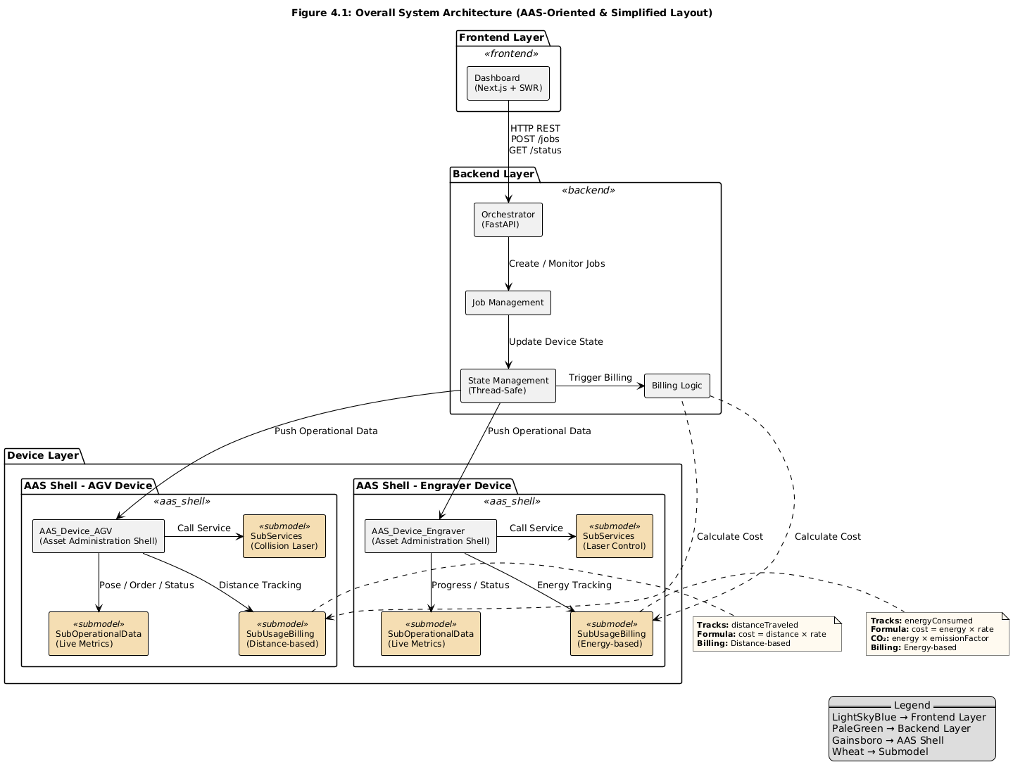
Figure 4.1 - Overall Architecture

At the frontend layer, a Next.js-based dashboard provides the user interface for job submission, real-time monitoring and billing visualization. The dashboard employs the SWR pattern to maintain responsive updates without requiring manual refresh actions, ensuring that users observe device status changes, progress updates and billing calculations as they occur. This presentation layer communicates exclusively with the backend orchestrator through RESTful API endpoints, maintaining a clean separation between user interface concerns and business logic.
The backend layer centres on a FastAPI based orchestrator that manages three core responsibilities: job lifecycle management, device state coordination and billing calculation orchestration. The job management component handles incoming requests from the dashboard, validates job parameters and maintains the queue of pending operations. State management ensures thread-safe coordination of device operations, preventing race conditions when multiple jobs execute concurrently or when devices transition between operational states. The billing logic component monitors device state transitions and triggers usage calculations at appropriate points in the operational workflow specifically when devices complete assigned tasks and transition their operational status to "Done." Billing logic resides in the orchestrator rather than individual devices. This centralized approach enables uniform policy enforcement and simplifies adding new device types without device-specific billing implementations. The tradeoff is orchestrator dependency devices cannot calculate costs during network outages. For factory environments with reliable connectivity, centralized billing provides better maintainability.
The device layer consists of AAS-compliant devices (AGV and laser engraver), each maintaining SubOperationalData and SubUsageBilling submodels. Detailed submodel specifications are presented in Section 4.2. The AGV's SubUsageBilling tracks distance travelled and calculates costs based on path length, while the Engraver's SubUsageBilling monitors energy consumption and derives both operational costs and carbon emissions. These submodels communicate through shared references specifically the orderRef attribute that links billing records to specific operational tasks, enabling the billing logic to attribute costs accurately to individual jobs even when devices process multiple tasks sequentially or when billing calculations occur asynchronously relative to task completion.
Communication follows RESTful principles. API endpoints follow AAS conventions with hierarchical paths reflecting submodel structure /api/v1/aas/{device}/{submodel}, enabling integration with standard AAS management tools. This consistent API structure aligns with AAS conventions where submodels are accessed through hierarchical paths that reflect their position within the asset's digital representation. The use of standard HTTP methods and JSON payloads ensures that the architecture could integrate with existing AAS management tools and repositories without requiring proprietary protocols or data formats.
Billing calculations trigger on device state transitions (e.g., status change to "Done") rather than polling or interrupting active operations. This event-driven approach adds <5ms overhead per state transition and requires no modifications to device control logic. When a device completes a task, its operational submodel updates status to "Done," which triggers the orchestrator to read accumulated usage data from the SubUsageBilling submodel and perform cost calculations. This event-driven approach ensures that billing tracking adds minimal computational overhead during active operations and concentrates processing during state transitions when devices are naturally idle.

4.2 Class Diagram (AAS Structure)
The SubUsageBilling submodel extends the AAS metamodel to capture usage metrics and derive costs specific to each device's operational characteristics. While both devices share a common structural pattern; tracking usage, applying rate parameters and calculating costs where the specific attributes differ based on whether billing depends on physical movement or energy consumption. Table 4.1 summarizes the attribute structure for both device types, highlighting shared attributes that enable consistent billing workflows and device-specific attributes that accommodate different usage models.
For the AGV, the primary usage metric is distanceTraveled, measured in meters and accumulated incrementally as the vehicle moves between locations. This attribute updates continuously during transport operations with the orchestrator calculating Euclidean distance between successive pose updates reported by the AGV. The costPerMeter attribute defines the billing rate denominated in EUR/m and represents a configurable parameter that could vary based on factors such as time of day, vehicle type or service-level agreements in a multi-stakeholder environment. The usageCost attribute stores the calculated billing amount in EUR derived by multiplying accumulated distance by the applicable rate when the transport task completes. The AGV's SubUsageBilling omits carbon emission attributes because electric vehicle movement generates negligible direct emissions during operation, though future extensions could incorporate embodied emissions from vehicle manufacturing or indirect emissions from electricity generation if the charging infrastructure were instrumented.
Figure 4.2 illustrates the complete class structure for the AGV's AAS implementation, showing how SubUsageBilling integrates with SubOperationalData through the orderRef attribute. This reference attribute contains the unique identifier of the current transport order enabling the billing system to attribute costs to specific tasks even when multiple orders execute sequentially on the same vehicle. The billingStatus attribute tracks the payment lifecycle through three states: "Open" indicates that usage costs have been calculated but not yet paid, "Paid" signifies completed payment processing and "Failed" marks billing records that encountered errors during payment attempts. State transitions typically follow the sequence Open → Paid for successful transactions, though error conditions or disputes could trigger transitions to Failed status requiring manual intervention or retry logic. The lastBilledAt timestamp records when the usage cost calculation occurred while lastUpdated captures when the usage metric most recently changed enabling audit trails and helping identify stale data if devices lose connectivity.
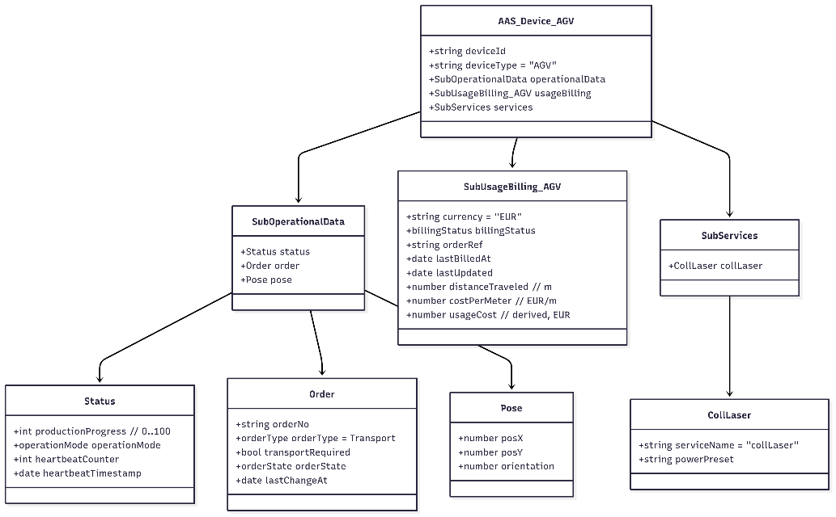
Figure 4.2 AGV Class Diagram
For the Engraver, the SubUsageBilling submodel tracks energyConsumed measured in kilowatt-hours (kWh), calculated based on laser activation time and calibrated power consumption parameters. Unlike distance, which accumulates smoothly and continuously, energy consumption exhibits stepwise behaviour tied to discrete engraving operations, idle periods contribute baseline power draw while active engraving consumes significantly more power proportional to laser intensity and duration. The costPerEnergyUnit parameter, denominated in EUR/kWh applies the prevailing electricity rate to convert energy usage into monetary costs. This parameter could reflect time-of-use pricing in scenarios where manufacturing operations shift energy-intensive tasks to off-peak hours or it could incorporate different rates for different stakeholders in shared factory arrangements where some parties have negotiated favourable energy contracts.
The Engraver's SubUsageBilling extends beyond pure cost tracking to include carbon footprint measurement through two additional attributes. The emissionFactor attribute, measured in gCO₂/kWh, represents the carbon intensity of the electrical grid supplying the factory. The emission factor (gCO₂/kWh) represents grid carbon intensity; in Germany, the average emissions for electricity generation in 2024 were approximately 360 gCO₂/kWh[22]. The carbonEmissions attribute stores the calculated environmental impact in grams of CO₂, derived by multiplying energy consumption by the emission factor. Including the emission factor within the device's SubUsageBilling submodel rather than retrieving it from an external service ensures that billing calculations remain self-contained and reproducible even if external APIs become unavailable. However, this design choice assumes either static emission factors or periodic manual updates; a production implementation might alternatively reference real-time grid carbon intensity data through a separate AAS submodel dedicated to environmental parameters.
Figure 4.3 presents the Engraver's complete class structure, illustrating the additional sustainability attributes alongside the standard billing fields shared with the AGV. The structural consistency between device types both include orderRef, billingStatus, usageCost and timestamp attributes that reflects a deliberate design decision to enable uniform billing workflows despite different underlying usage models. The orchestrator's billing logic can apply a common processing pattern: detect task completion through SubOperationalData status changes, retrieve accumulated usage metrics from SubUsageBilling and apply rate parameters to calculate costs, update billing status and record timestamps. Device-specific calculations occur within specialized functions that understand whether to multiply distance by distance rates or energy by energy rates, but the overall workflow structure remains consistent.
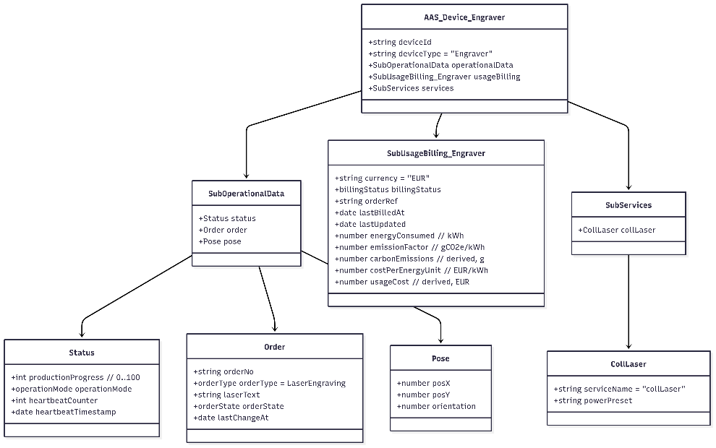
Figure 4.3 Laser Engraver Class Diagram

The relationship between SubOperationalData and SubUsageBilling operates through loose coupling via the orderRef attribute rather than tight structural dependencies. When a device begins executing a task, the orchestrator assigns an order identifier and writes it to both the operational and billing submodels. As the task progresses, operational state changes which pose updates for the AGV, progress increments for the Engraver trigger corresponding updates to usage metrics in the billing submodel. When SubOperationalData transitions to "Done" status, the orchestrator recognizes this as a billing trigger, reads the accumulated usage values, performs cost calculations and updates the billing status. This event-driven integration pattern ensures that billing tracking remains synchronized with operational workflows without requiring bidirectional references or complex state synchronization protocols between submodels.
The attribute design emphasizes auditability and transparency, particularly important in multi-stakeholder contexts where cost allocation disputes could arise. Every billing record includes not just the final calculated cost but also the underlying usage metric, the rate parameter applied and timestamps documenting when usage occurred and when billing calculations executed. This comprehensive record enables stakeholders to verify billing accuracy by recomputing costs from logged usage data and the immutable nature of historical billing records provides evidence for dispute resolution. The explicit separation of usage metrics (distanceTraveled, energyConsumed) from derived costs (usageCost) also supports scenarios where rate parameters change mid-operation or where different stakeholders face different rates the raw usage data remains objective and verifiable regardless of pricing policies.
Attribute | AGV (Distance-based) | Engraver (Energy-based) | Purpose
Primary Usage Metric | distanceTraveled (number, meters) | energyConsumed (number, kWh) | Core billable metric
Cost Rate Parameter | costPerMeter (number, EUR/m) | costPerEnergyUnit (number, EUR/kWh) | Defines unit pricing rate
Calculated Cost | usageCost (number, EUR) | usageCost (number, EUR) | Derived total billing amount
Billing Status | billingStatus (enum: Open / Paid / Failed) | billingStatus (enum: Open / Paid / Failed) | Tracks payment processing state
Order Reference | orderRef (string) | orderRef (string) | Links the billing entry to an operational order
Sustainability Metric | - | emissionFactor (number, gCO₂/kWh) | Quantifies environmental impact per energy unit
Calculated Emissions | - | carbonEmissions (number, g) | Derived total CO₂ emissions
Timestamp (Billing) | lastBilledAt (datetime, ISO 8601) | lastBilledAt (datetime, ISO 8601) | Records the last billing computation time
Timestamp (Usage) | lastUpdated (datetime, ISO 8601) | lastUpdated (datetime, ISO 8601) | Indicates last sensor metric update
Table 4.1: SubUsageBilling Submodel Attributes for AGV and Engraver Devices

4.3 Sequence Diagrams
The operational workflows for both device types follow similar patterns such as job initiation, progressive state updates during execution, completion detection and billing calculation while differing in the specific metrics tracked and calculation methods applied. Figures 4.4 and 4.5 illustrate these workflows through sequence diagrams that show temporal orchestration of interactions between user, dashboard, orchestrator, device and AAS submodels.
For AGV transport operations, the workflow begins when a user submits a transport request through the dashboard, specifying pickup and dropoff locations. The orchestrator receives this request, generates a unique order reference identifier and initializes both the SubOperationalData and SubUsageBilling submodels with this reference. The AGV then receives the transport assignment and updates its operational status to "Running" while beginning navigation toward the pickup location. During movement, the AGV continuously reports pose updates x and y coordinates in the factory coordinate system to its SubOperationalData submodel. The orchestrator monitors these pose changes and calculates incremental distance travelled using Euclidean distance between successive positions. Each distance increment accumulates in the SubUsageBilling submodel's distanceTraveled attribute, with the lastUpdated timestamp recording when the most recent position update occurred.
The transport workflow proceeds through three distinct movement phases: navigation from dock to pick up location, transport from pickup to drop off with loaded material and return from drop off to dock. All three phases contribute to the accumulated distance metric, though the billing rules could potentially differentiate between loaded and unloaded travel if business requirements demanded such granularity. When the AGV reaches the drop off location and completes material unloading, it updates its operational status to "Done," which triggers the orchestrator's billing calculation logic. The orchestrator reads the accumulated distanceTraveled value and the configured costPerMeter rate parameter, multiplies these values to derive usageCost and updates the billing submodel with the calculated cost, setting billingStatus to "Open" and recording the calculation timestamp in lastBilledAt. The dashboard then retrieves this billing information through a GET request to the AGV's billing submodel endpoint and displays the completed job with associated usage cost to the user.
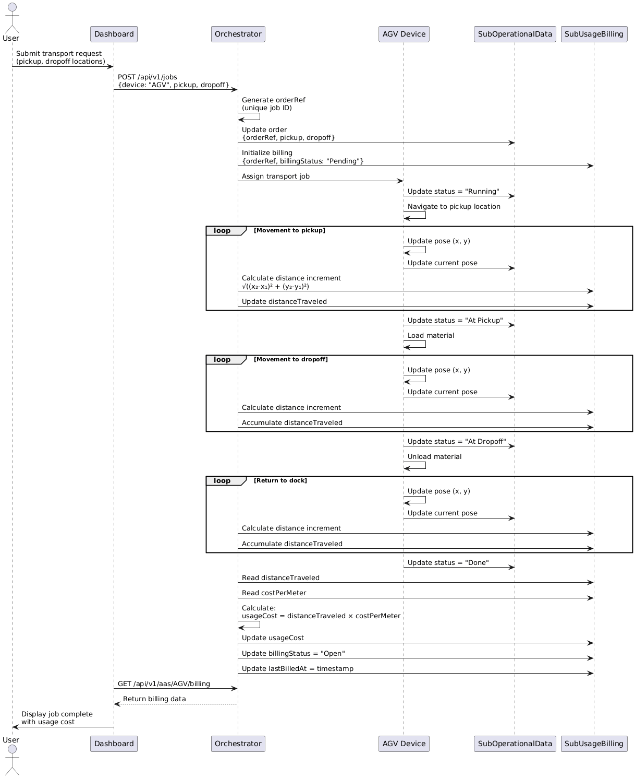
Figure 4.4 AGV Sequence Diagram
For engraving operations, the workflow exhibits different tracking characteristics due to the energy-based billing model. Users submit engraving jobs by specifying the text to be engraved, with the system calculating expected duration based on character count, each letter requires approximately 0.5 seconds of laser activation time. The orchestrator initializes the job similarly to AGV transport, creating an order reference and preparing both operational and billing submodels. As the Engraver begins processing, it updates its operational status to "Running" and reports progress as a percentage from 0% to 100%. Unlike the AGV's continuous spatial movement, the Engraver's progress increments discretely as each character completes, though the underlying time-based energy calculation treats duration as a continuous variable.
The orchestrator monitors progress updates and calculates accumulated energy consumption based on elapsed time since job start. The energy model incorporates both baseline idle power draw representing cooling systems, control electronics and other constant overhead, and variable laser power consumption proportional to active engraving time. As progress advances, the orchestrator continuously updates the energyConsumed attribute in SubUsageBilling, enabling real-time visibility into accumulating costs and environmental impact even before job completion. When progress reaches 100% and operational status transitions to "Done," the orchestrator performs final billing calculations by multiplying accumulated energy by the configured costPerEnergyUnit rate to derive monetary cost and by the emissionFactor to calculate carbon emissions in grams of CO₂. Both calculated values update in the billing submodel simultaneously, with billingStatus transitioning to "Open" to indicate that billing records await payment processing.
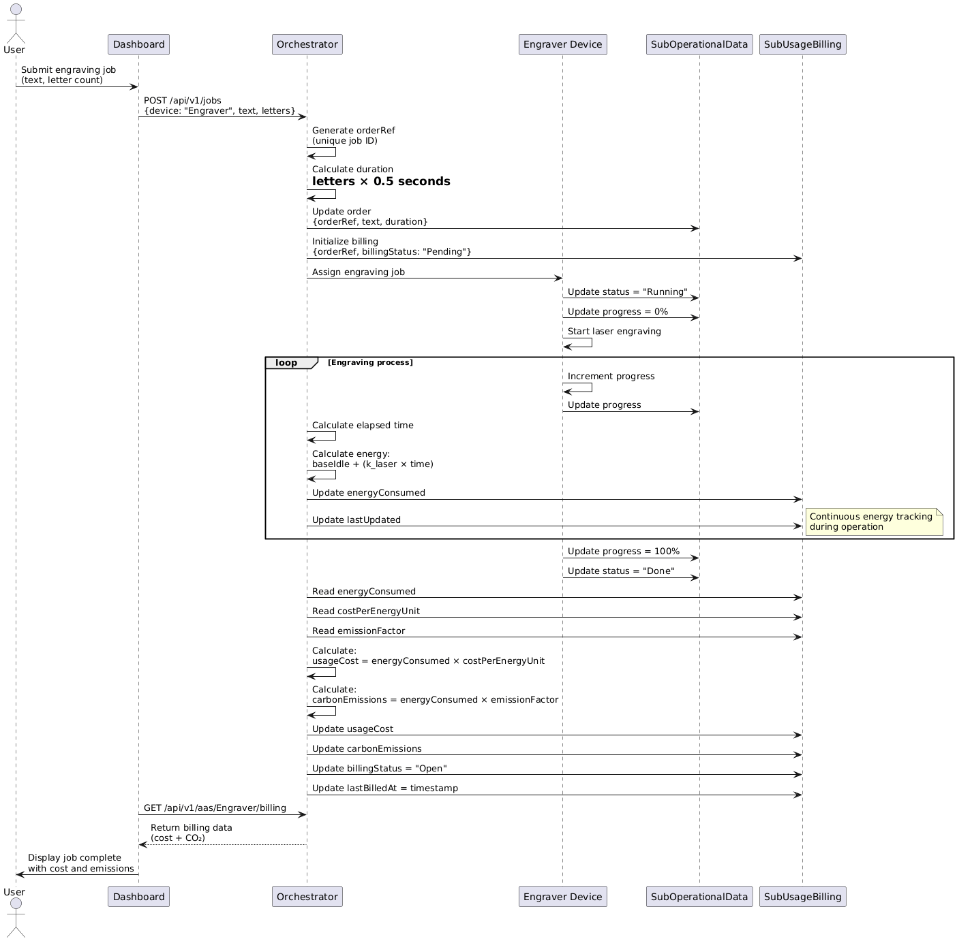
Figure 4.5 Laser Engraver Sequence Diagram

The sequence diagrams reveal several critical integration points where billing data capture synchronizes with operational workflows. First, both workflows initialize billing records at job assignment time, establishing the orderRef link before any billable usage occurs. This pre-emptive initialization ensures that all subsequent usage data correctly associates with the originating job even if devices process multiple jobs concurrently or in rapid succession. Second, usage metrics update during job execution rather than only at completion, supporting real-time cost visibility and enabling early intervention if jobs exceed expected budgets. Third, billing calculations trigger explicitly on operational status transitions to "Done" rather than relying on periodic polling or timer-based checks, ensuring that billing always reflects actual task completion and avoiding premature calculations if jobs pause or encounter errors mid-execution.
The non-intrusive nature of billing integration becomes evident through the separation of concerns visible in the sequence diagrams. Devices update their operational submodels pose for AGV, progress for Engraver using the same patterns they would employ without any billing system present. The orchestrator observes these standard operational updates and derives billing-relevant metrics independently, writing to the SubUsageBilling submodel without requiring devices to implement billing-aware logic. This architectural separation means that devices remain unaware of cost calculations, rate parameters or payment workflows maintaining focus on their core operational functions. If billing services become temporarily unavailable due to network issues or system maintenance, devices continue reporting operational state normally, with usage data accumulating in their submodels until billing services restore and can process accumulated records retroactively.

4.4 Billing Rules
The billing calculations translate raw usage metrics into monetary costs through device-specific formulas that reflect the physical and economic characteristics of each operation type. Table 4.2 summarizes the parameters and values used in the simulation implementation, chosen to represent realistic operational conditions while remaining simple enough for validation and verification purposes.
Parameter | Device | Value | Unit | Rationale
costPerMeter | AGV | 0.02 | EUR/m | Representative industry rate for internal logistics
distanceCalculationMethod | AGV | Euclidean | — | $\sqrt{((x₂-x₁)² + (y₂-y₁)²)}$for 2D factory floor distance computation
baseIdlePower | Engraver | 0.02 | kWh | Constant overhead for cooling, control electronics, and idle laser state
k_laser (Laser Coefficient) | Engraver | 0.002 | kWh/sec | Power consumption rate during active engraving
timePerLetter | Engraver | 0.5 | seconds | Average estimated engraving duration per character
costPerEnergyUnit | Engraver | 0.40 | EUR/kWh | Average industrial electricity tariff in Germany
emissionFactor | Engraver | 360 | gCO₂/kWh | Carbon intensity of German electricity grid (2023)
Table 4.2 Billing Logic
For the AGV, the billing formula implements a straightforward linear relationship between distance travelled and cost: usageCost = distanceTraveled × costPerMeter. The distance calculation employs Euclidean geometry to measure straight-line distance between successive pose updates reported by the vehicle. When the AGV moves from position (x₁, y₁) to position (x₂, y₂), the incremental distance equals $\sqrt{((x₂-x₁)² + (y₂-y₁)²)}$, with all coordinates expressed in meters within the factory's coordinate system. The simulation accumulates these incremental distances throughout the transport operation, summing contributions from all three movement phases: initial navigation from dock to pick up location, loaded transport from pickup to drop off and return journey from drop off to dock. The costPerMeter parameter, set at €0.02 per meter for simulation purposes, represents a plausible rate for internal logistics services that accounts for vehicle amortization, maintenance, energy consumption and operational overhead without attempting precise cost modelling for any specific facility.
The AGV billing rules incorporate selective distance tracking that distinguishes between billable and non-billable movement segments. Transport operations from dock to pick up location, pickup to drop off with loaded material and drop off back to dock all contribute to the accumulated distance metric. However, movement from the AGV's home charging station to the dock representing positioning moves before accepting job assignments does not increment billable distance, as such movements serve internal operational needs rather than customer-requested services. This distinction illustrates how billing rules can encode business logic that differentiates between value-generating activities deserving cost attribution and internal preparatory movements that constitute operational overhead. The simulation implements this distinction by initializing distance tracking only after job assignment and before the first movement toward the pickup location, ensuring that the distanceTraveled attribute reflects only job-related movement.
The choice of distance-based billing for the AGV reflects the operational reality that transport services consume resources proportional to travel distance. Longer routes require more time, deplete battery charge faster and contribute more wear to mechanical components than shorter routes. While alternative billing models could charge per transport job regardless of distance or incorporate time-based components to account for traffic congestion or waiting periods, the distance-based approach provides transparent and easily verified cost attribution. Stakeholders can independently measure distances between locations and validate calculated charges, reducing potential for disputes in multi-party environments. The linear relationship between distance and cost represents a simplification real-world operation might exhibit economies of scale where per-meter costs decrease for longer routes or premium pricing for expedited short-distance deliveries, but the linear model establishes a clear baseline that subsequent research or production implementations could refine based on empirical data.
For the Engraver, billing calculations reflect the energy-intensive nature of laser operations through a time-dependent power consumption model. The total energy consumed during an engraving job combines constant baseline power with variable laser power: energyConsumed = baseIdlePower + (k_laser × power_factor × time_seconds). The baseline idle power of 0.02 kWh represents continuous overhead from cooling systems, motion control electronics and auxiliary equipment that operate regardless of whether the laser actively engraves. The laser-specific coefficient k_laser, set at 0.002 kWh per second, quantifies incremental power consumption when the laser fires. The simulation calculates total operation time as time_seconds = letterCount × 0.5, estimating that each character requires half a second to engrave based on typical laser traversal speeds and marking depths. Multiplying accumulated energy by the costPerEnergyUnit parameter of €0.40 per kWh representative of industrial electricity rates in Germany yields the monetary usage cost: usageCost = energyConsumed × costPerEnergyUnit.
The Engraver's billing submodel extends beyond cost calculation to quantify environmental impact through carbon emission tracking. The formula carbonEmissions = energyConsumed × emissionFactor multiplies the job's total energy consumption by the carbon intensity of the electrical grid, expressed in grams of CO₂ per kilowatt-hour. The emission factor of 360 gCO₂/kWh represents Germany's electricity grid average when accounting for the country's energy mix of renewable sources, natural gas and coal. This value fluctuates temporally renewable generation peaks during sunny, windy periods reduce instantaneous carbon intensity, while evening demand relying on fossil fuel plants increases it; but the simulation employs a static average value for consistency and reproducibility. Production implementations could enhance accuracy by retrieving real-time grid carbon intensity data from national energy authorities or integrating with services that provide location-specific and time-varying emission factors, enabling more precise environmental impact attribution.
The parameter values listed in Table 4.2 balance realism with pedagogical clarity. The rates chosen €0.02 per meter for transport, €0.40 per kWh for electricity align with typical European industrial costs without claiming precise accuracy for any specific facility or operational context. The energy consumption coefficients for the Engraver derive from representative laser system specifications rather than measurements from actual hardware, as the simulation-based validation approach prioritizes demonstrating architectural feasibility over achieving exact physical fidelity. Production deployment requires empirical calibration, potentially revealing non-linearities (economies of scale, threshold effects) or dependencies (material properties, temperature, equipment age) not captured in simplified models. The architecture accommodates refinements replacing formulas with lookup tables or ML models requires modifying orchestrator calculation logic without changing SubUsageBilling structure or device integration.

4.5 Integration Points with Existing AAS Infrastructure
SubUsageBilling integrates with AAS infrastructure through three mechanisms: (1) orderRef-based coupling to SubOperationalData, (2) hierarchical API endpoints following AAS path conventions, (3) event-driven billing updates triggered by operational state changes. The simulation implements these patterns without connecting to actual AAS registries production deployment requires integration with IDTA-compliant infrastructure. This integration strategy ensures that the billing extension remains optional and non-disruptive, allowing devices to function normally whether billing capabilities are active.
OrderRef-based coupling (detailed in Section 4.2) links operational tasks to billing records, enabling accurate cost attribution across device lifecycles. As the device executes its assigned task and updates operational parameters such as pose, progress or status, these changes implicitly drive corresponding updates in billing metrics. This reference-based coupling remains loose enough that operational and billing submodels can evolve independently adding new operational parameters or billing metrics requires no changes to the linking mechanism while tight enough to ensure accurate cost attribution even when devices process jobs rapidly in succession.
The API endpoint structure follows AAS naming conventions that organize submodel access through hierarchical paths reflecting the asset structure. Operational data resides at /api/v1/aas/{deviceId}/submodels/operational, where GET requests retrieve status and progress while POST or PATCH requests update state during job execution. Billing data appears at /api/v1/aas/{deviceId}/submodels/billing, with GET requests returning accumulated usage metrics and calculated costs while POST requests initialize new billing records at job start. This consistent URL structure aligns with AAS specifications that treat submodels as collections of properties accessible through standard HTTP methods, enabling the billing extension to integrate seamlessly with existing AAS management tools, repositories and client applications that already understand how to navigate asset hierarchies and retrieve submodel data. These endpoint patterns represent architectural intent the simulation's in-memory implementation does not expose external HTTP APIs. Real AAS registry integration would require deploying devices as network-accessible services with persistent endpoints.
The SubUsageBilling submodel structure adheres to AAS metamodel principles that govern how submodels represent asset properties. Each attribute within the submodel corresponds to a SubmodelElement in AAS terminology, with defined semantic identifiers, data types and access permissions. The distanceTraveled attribute, for instance, could reference a semantic identifier from an industry ontology that precisely defines what "distance traveled" means, cumulative path length in meters, measured in two-dimensional factory floor coordinates, excluding positioning movements while enabling unambiguous interpretation by any system consuming the billing data. This semantic precision becomes critical in multi-stakeholder environments where billing disputes might arise having clearly defined, standardized semantics for billing attributes reduces ambiguity and supports automated validation of billing records against agreed-upon definitions.
The architecture's compatibility with AAS standards positions SubUsageBilling as a candidate for standardization through the Industrial Digital Twin Association (IDTA), which maintains registries of approved submodel templates. If SubUsageBilling proved valuable across multiple organizations and application domains, it could undergo a standardization process like existing submodels like Nameplate or Technical Data, resulting in an official template that manufacturers could implement consistently. Standardization would establish canonical semantic identifiers for all billing attributes, define mandatory versus optional properties, specify data types and units precisely and potentially enumerate common billing methods that implementations should support. However, achieving IDTA-approved status requires multi-year community review, hardware validation across vendors and demonstrated industry adoption none of which this simulation-based research provides. SubUsageBilling currently represents a proof-of-concept submodel proposal, not a standardized template. Such standardization would enable true interoperability where devices from different vendors could expose usage billing data through identical interfaces and where billing systems from third-party providers could consume this data without requiring device-specific integration code.

4.6 Scalability Considerations
The architecture supports multiple concurrent devices through independent AAS instances that maintain isolated billing state. Each device whether AGV, Engraver, or future device types, possesses its own SubUsageBilling submodel with dedicated attributes for usage metrics, cost calculations and billing status. This instance-level isolation prevents interference between simultaneous operations: multiple AGVs can execute transport jobs concurrently without their distance tracking conflicting and the Engraver can process jobs while AGVs operate, with each device's billing calculations proceeding independently. The orchestrator's thread-safe state management ensures atomic updates to billing attributes even when multiple API requests arrive simultaneously.
Extensibility to additional device types follows the established pattern demonstrated by AGV and Engraver implementations. A CNC machine could track material removal volume and spindle hours, a robotic arm could bill based on operation cycles and payload weight and conveyor systems could charge for throughput volume and transport distance. Each new device type would define its SubUsageBilling attributes to match its operational characteristics, the specific metrics tracked and formulas applied would vary; while maintaining the common structural elements like orderRef, billingStatus, usageCost and timestamps that enable uniform billing workflows. The orchestrator's billing logic would require device-specific calculation functions, but the overall integration pattern of observing operational state changes, accumulating usage metrics and triggering calculations at task completion would remain consistent across device types.

5. Implementation

5.1 JSON Mock of AAS Submodel
These JSON structures represent in-memory simulation data, not AAS-compliant AASX packages. Production deployment requires exporting to AASX format with complete metamodel annotations (semantic IDs, data specifications, access control) not implemented here. Code Blocks 5.1 and 5.2 present simplified versions highlighting the key attributes, with complete schemas including all metadata fields provided in Appendix A.
Code Block 5.1: AGV Asset Administration Shell JSON Structure
{
"deviceId": "agv-001",
"deviceType": "AGV",
"operationalData": {
"status": {
"operationMode": "Running",
"productionProgress": 50
},
"order": {
"orderNo": "ORD-123",
"orderType": "Transport",
"orderState": "InProcess"
},
"pose": {
"posX": 5.2,
"posY": 3.1,
"orientation": 90.0
}
},
"usageBilling": {
"orderRef": "ORD-123",
"distanceTraveled": 15.5,
"costPerMeter": 0.05,
"usageCost": 0.775,
"billingStatus": "Open",
"currency": "EUR"
}
}
The AGV's JSON structure separates operational state from billing data while maintaining their connection through the shared order reference. The operational data submodel captures the vehicle's current pose with x and y coordinates in meters (posX: 5.2, posY: 3.1) relative to the factory's origin point, along with orientation in degrees. The status object tracks operation mode and production progress, enabling the orchestrator to monitor job execution state. The order object links operational activities to specific tasks through the order number, with order state progressing from "InProcess" to "Done" when transport completes. The usage billing submodel contains distanceTraveled accumulated during job execution, showing 15.5 meters for this example transport. Multiplying this distance by the costPerMeter rate of €0.05 yields the usageCost of €0.775. The billingStatus of "Open" indicates that the cost has been calculated but payment processing has not yet occurred.
Code Block 5.2: Engraver Asset Administration Shell JSON Structure
{
"deviceId": "engraver-001",
"deviceType": "Engraver",
"operationalData": {
"status": {
"operationMode": "Running",
"productionProgress": 75
},
"order": {
"orderNo": "ORD-123",
"orderType": "LaserEngraving",
"laserText": "Hello World",
"orderState": "InProcess"
}
},
"usageBilling": {
"orderRef": "ORD-123",
"energyConsumed": 2.5,
"costPerEnergyUnit": 0.30,
"emissionFactor": 360,
"carbonEmissions": 1250.0,
"usageCost": 0.75,
"billingStatus": "Open",
"currency": "EUR"
}
}
The Engraver's structure mirrors the AGV's organizational pattern operational data and usage billing submodels linked by order reference while tracking different metrics appropriate to energy-based billing. The operational data submodel uses productionProgress as a percentage rather than spatial coordinates, incrementing from 0 to 100 as the engraving job advances. The order object stores the text to be engraved ("Hello World") along with order type and state information. The usage billing submodel records energyConsumed of 2.5 kWh for this job, comprising baseline idle power plus laser activation energy accumulated during operation. The monetary cost calculation multiplies energy by costPerEnergyUnit of €0.30/kWh, yielding usageCost of €0.75. The environmental impact calculation multiplies the same energy consumption by emissionFactor of 360 gCO₂/kWh, producing carbonEmissions of 1250.0 grams. This dual calculation cost and carbon from the same energy metric demonstrates how a single usage measurement serves both economic and environmental accounting purposes.
Both JSON structures exhibit design choices that balance completeness with simplicity. The flat organization within each submodel billing attributes appear as direct properties rather than deeply nested objects which simplifies programmatic access and reduces the complexity of update operations. The orchestrator can read distanceTraveled directly without navigating multiple nesting levels. Numerical values use appropriate precision: distances carry one decimal place, energy values use one decimal place, while costs maintain three decimal places to avoid rounding errors in monetary calculations. The consistent placement of orderRef, billingStatus and currency fields across both device types enables generic billing workflows that handle different device types through parameterization rather than device-specific code paths.
The JSON structures conform to AAS metamodel principles by organizing information into submodels that represent distinct aspects of the asset. The operationalData submodel corresponds to the standard SubOperationalData specification, capturing real-time device state, while the usageBilling submodel implements the proposed SubUsageBilling extension for cost tracking. Each device maintains its unique identifier (deviceId) and type classification (deviceType), enabling the orchestrator to route requests appropriately and apply device-specific billing logic. The structures also support extensibility: adding new billing metrics like peak power demand for the Engraver or payload weight for the AGV would require only inserting additional key-value pairs in the usage billing submodel without disrupting existing attributes or requiring schema migration for historical data. Complete JSON schemas including heartbeat counters, timestamps and all metadata fields are provided in Appendix A.

5.2 Simulation Environment
The backend translates architectural specifications into executable Python using FastAPI. Key implementation challenges addressed:
Thread-Safe State Management: In-memory dictionary with threading locks prevents race conditions during concurrent job submissions and device updates.
Incremental Usage Tracking: Distance and energy calculations update continuously during operations rather than only at completion, enabling real-time cost visibility.
Event-Driven Billing: Orchestrator observes device state transitions (status → "Done") to trigger billing calculations without requiring devices to invoke billing APIs.
This section highlights implementation patterns for these challenges. Complete source code (500+ lines) appears in Appendix B as reference but is not discussed line-by-line.
- Distance Calculation for AGV Transport
The AGV's billing system relies on accurate distance measurement as the vehicle moves through the factory coordinate space. Code Block 5.3 shows the fundamental distance calculation function that computes Euclidean distance between two points using Python's math.hypot() function, which provides numerically stable computation of the square root of the sum of squares.
Code Block 5.3: Euclidean Distance Calculation
def dist(a: Tuple[float, float], b: Tuple[float, float]) -> float:
"""Calculate Euclidean distance between two points"""
ax, ay = a
bx, by = b
return math.hypot(bx - ax, by - ay)
This distance function serves as the foundation for tracking AGV movement. The orchestrator applies it repeatedly as the vehicle moves incrementally toward target locations, accumulating distance only during billed segments of the journey. Code Block 5.4 demonstrates the AGV movement logic that updates position, calculates distance traveled, and conditionally accumulates billable distance based on whether the current movement segment falls within a billing window.
Code Block 5.4: AGV Movement with Distance Tracking
def _agv_move_to(self, target_xy: Tuple[float, float], billed: bool = False) -> None:
"""Move AGV to target position"""
pose = self.agv["operationalData"]["pose"]
speed = self.config["agv"]["speed_m_per_s"]
step = speed * 0.1 # 100ms time steps
self._toggle_billing(billed)
start_xy = (pose["posX"], pose["posY"])
self.agv["operationalData"]["status"]["operationMode"] = "Running"
while True:
before = (pose["posX"], pose["posY"])
arrived = move_pose_towards(pose, target_xy, step)
after = (pose["posX"], pose["posY"])
moved = dist(before, after)
# Accumulate distance only if in billing window
if self.billing_window_active:
self.agv["usageBilling"]["distanceTraveled"] += moved
bump_heartbeat(self.agv)
if arrived:
break
time.sleep(0.1) # 100ms simulation step
self.agv["operationalData"]["status"]["operationMode"] = "Idle"
The movement function implements a simulation loop that advances the AGV's position in discrete time steps of 100 milliseconds. Each iteration calculates the distance moved during that step and accumulates it to the distanceTraveled attribute only when billing_window_active is true. This selective accumulation enables the billing rules described in Section 4.4, where movement from home position to dock does not contribute to billable distance, but subsequent transport operations do. The heartbeat counter increments with each update, providing a mechanism for detecting communication failures if the dashboard observes stale heartbeat values.
- Energy Calculation for Laser Engraving
The Engraver's billing model calculates energy consumption based on job duration and power consumption characteristics. Code Block 5.5 presents the energy calculation logic embedded within the job execution function, showing how baseline idle power and laser-specific power combine to determine total energy usage.
Code Block 5.5: Energy Consumption Calculation
def run_engrave_job(device: Dict[str, Any], orderNo: str, laserText: str,
config: Dict[str, Any]) -> Dict[str, Any]:
"""Run engraving job with energy calculation"""
# Calculate runtime based on text length
letters = len(laserText or "")
seconds_per_letter = config["engraver"]["seconds_per_letter"]
total_time_s = max(1.0, letters * seconds_per_letter)
# Simulate progress with time delays
total_loops = int(100 / progress_step)
sleep_per_loop = total_time_s / total_loops
while device["operationalData"]["status"]["productionProgress"] < 100:
bump_heartbeat(device)
set_progress(device, device["operationalData"]["status"]["productionProgress"] + progress_step)
time.sleep(sleep_per_loop)
The energy calculation implements the formula specified in Section 4.4, combining constant baseline power consumption with laser-specific power that scales linearly with operation time. The function calculates total job duration based on character count, simulates progress increments with appropriate time delays to mimic real engraving speed, then performs final energy and cost calculations when the job completes. The dual calculation of monetary cost and carbon emissions from the same energy metric demonstrates the efficiency of measuring environmental impact alongside economic costs while both derive from a single physical measurement without requiring separate instrumentation.
- Billing Calculation Functions
When devices complete assigned tasks, the orchestrator triggers billing calculations that apply rate parameters to accumulated usage metrics. Code Block 5.6 shows the billing logic for both device types, demonstrating how simple multiplication operations transform raw usage data into monetary costs.
Code Block 5.6: Billing Calculations for AGV and Engraver
# AGV billing calculation
def calculate_agv_billing(agv: Dict[str, Any], order_ref: str) -> None:
"""Calculate and update AGV billing"""
ub = agv["usageBilling"]
ub["distanceTraveled"] = round(ub["distanceTraveled"], 6)
# Formula: Cost = Distance × Rate
ub["usageCost"] = round(ub["distanceTraveled"] * ub["costPerMeter"], 6)
ub["orderRef"] = order_ref
ub["billingStatus"] = "Open"
# Engraver billing (calculated within run_engrave_job)
# Energy: base_idle + (k_laser × power_factor × time)
# Cost: energy × costPerEnergyUnit
# CO2: energy × emissionFactor
# Combined billing summary
The billing calculations demonstrate the straightforward translation of formulas from Section 4.4 into executable code. The AGV calculation multiplies accumulated distance by the configured rate, while the Engraver calculation performed during job execution multiplies energy consumption by both the cost rate and emission factor to produce monetary cost and environmental impact simultaneously. The combined billing summary aggregates costs from both devices, enabling total job cost calculation for scenarios where transport and engraving operations occur as part of a single workflow.
- FastAPI Endpoint Implementation
The backend exposes RESTful API endpoints that enable the dashboard to retrieve device state, billing information, and operational status. Code Block 5.7 presents an endpoint that returns combined billing data for both devices, demonstrating how the API layer accesses the shared state and formats responses according to AAS conventions.
Code Block 5.7: FastAPI Combined Billing Endpoint
@router.get("/combined-billing")
async def get_combined_billing():
"""GET combined billing data for both devices"""
state = get_state()
engraver = state.get_device("engraver")
agv = state.get_device("agv")
if not engraver or not agv:
raise HTTPException(status_code=500, detail="Device data not available")
# Get cumulative billing data
cumulative = state.get_cumulative_billing()
user_billing = cumulative["user_jobs"]
# Return combined billing response
return {
"engraver": {
"orderRef": f"USER-JOBS ({len(user_billing['jobs_processed'])} jobs)"
The endpoint demonstrates RESTful API design following AAS conventions where hierarchical paths reflect the structure of asset data. The implementation retrieves device data through thread-safe state access methods, aggregates billing information across multiple jobs, and returns a JSON response structured for easy consumption by frontend components. Error handling through HTTP exceptions ensures that clients receive appropriate status codes when devices are unavailable or state corruption occurs.
- Thread-Safe State Management
The simulation supports concurrent access from multiple API endpoints and background job execution tasks through thread-safe state management. Code Block 5.8 shows the locking mechanism that prevents race conditions when multiple threads read or modify device state simultaneously.
Code Block 5.8: Thread-Safe Device State Access
class SimulationState:
"""Thread-safe singleton state for the simulation"""
def __init__(self):
self._lock = threading.Lock() # Main state lock
self._cycle_lock = threading.Lock() # Separate cycle execution lock
self.reset_to_defaults()
def get_device(self, device_id: str) -> Optional[Dict[str, Any]]:
"""Get device by ID with thread-safe access"""
with self._lock: # Acquire lock before accessing shared state
if device_id == "engraver":
return copy.deepcopy(self.engraver) # Return deep copy
elif device_id == "agv":
return copy.deepcopy(self.agv)
return None
def update_config(self, updates: Dict[str, Any]) -> Dict[str, Any]:
"""Update configuration atomically"""
with self._lock: # Acquire lock for atomic updates
# Update configuration parameters
if "engraver" in updates:
for key, value in updates["engraver"].items():
if value is not None and key in self.config["engraver"]:
self.config["engraver"][key] = value
# Propagate changes to device billing rates
self.engraver["usageBilling"]["costPerEnergyUnit"] = \
self.config["engraver"]["costPerEnergyUnit_EUR_per_kWh"]
self.agv["usageBilling"]["costPerMeter"] = \
self.config["agv"]["costPerMeter_EUR"]
return copy.deepcopy(self.config)
The state management implementation employs Python's threading locks to ensure atomic access to shared device data. The get_device() method acquires the lock before accessing device dictionaries and returns deep copies rather than references to shared state, preventing external code from inadvertently modifying internal state without proper synchronization. The separate _cycle_lock prevents concurrent cycle executions only one background job can run at a time while still allowing read-only API requests to proceed. This dual-lock strategy balances safety against concurrency, enabling the dashboard to retrieve real-time status updates even while long-running simulation cycles execute in background threads. The complete state management implementation, including initialization, reset functionality, and cumulative billing tracking, appears in Appendix B.

5.3 Dashboard Implementation
The frontend dashboard provides real-time visibility into device operations, job execution progress and billing calculations through a web-based interface built with Next.js and React. The interface organizes information into three primary views: real-time device monitoring, billing reports with cost breakdowns and job submission controls. These views enable users to observe system behaviour, verify billing accuracy and interact with the simulation through intuitive graphical components.
Real-Time Device Monitoring
Figure 5.1 presents the real-time monitoring view that displays current operational status for both the AGV and Engraver. Each device appears in a dedicated card showing critical operational parameters including operation mode (Idle, Running, or Done), production progress as a percentage, current order details and device-specific metrics. The AGV card displays live position coordinates (X, Y, orientation) that update continuously as the vehicle moves through the factory space, enabling users to track transport operations visually. The Engraver card shows production progress incrementing from 0% to 100% during job execution, with the laser text being engraved displayed in the order information. Both cards include heartbeat counters that increment with each state update, providing a mechanism to detect communication failures if counter values become stale.
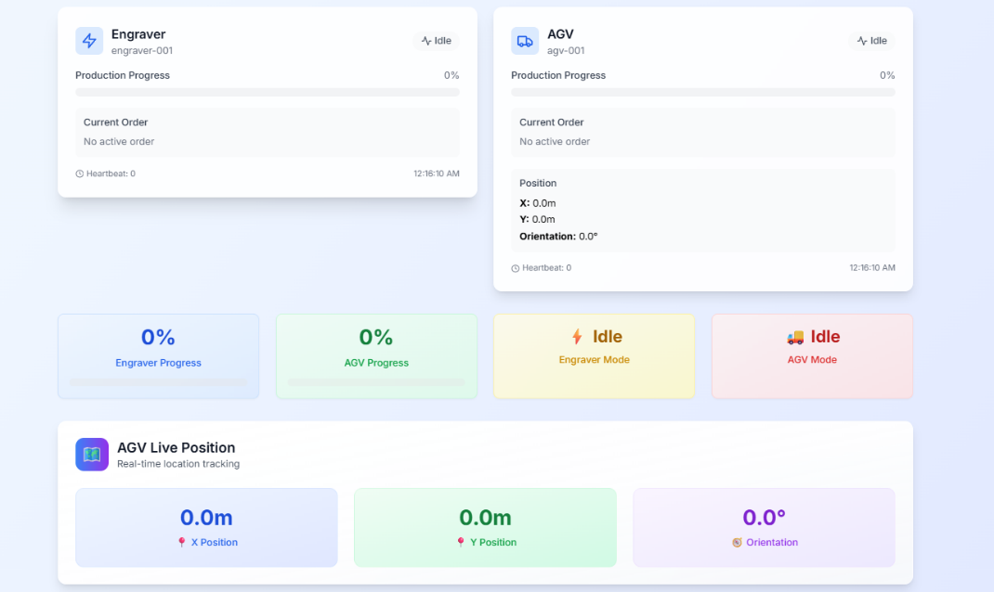
Figure 5.1 Real Time Device monitoring
The monitoring view implements the SWR pattern to maintain data freshness without requiring manual page refreshes. React components poll the FastAPI backend at regular intervals typically every 500 milliseconds during active operations retrieving updated device state from the /api/v1/aas/{device}/operational/status endpoints. When devices transition between operational modes or update progress values, these changes appear in the interface within one polling cycle, creating the perception of real-time updates. The use of SWR ensures that users observe cached data immediately while background requests fetch fresh information, preventing the interface from appearing unresponsive during network latency.
Billing Report Display
The billing report view, shown in Figure 5.2, presents comprehensive cost breakdowns for completed jobs with separate sections for individual job details and cumulative totals. Each job entry in the breakdown displays the engraved text, energy consumption in kilowatt-hours, carbon emissions in grams and monetary cost for the engraving operation, alongside AGV transport distance in meters and associated transport cost. The total cost per job combines both engraver and AGV expenses, providing a complete picture of resource consumption for each manufacturing task. The cumulative summary at the bottom aggregates metrics across all processed jobs, showing total jobs completed (3), total characters engraved (14 letters), total energy consumed (0.074 kWh), total carbon emissions (31.08 g) and the combined cost of €0.454.
The billing interface demonstrates the transparency enabled by usage-based tracking users can verify that costs derive directly from measurable operational metrics rather than arbitrary estimates. The side-by-side presentation of engraver energy costs and AGV transport costs illustrates how different billing models coexist within a unified framework. For the example jobs shown, transport costs (€0.425205) significantly exceed engraving costs (€0.0296), reflecting the longer distances traveled by the AGV compared to the relatively short duration of laser operations on small text strings. This cost distribution would shift dramatically for longer engraving jobs or shorter transport distances, demonstrating how usage-based billing adapts to actual operational patterns rather than applying fixed rates regardless of resource consumption.
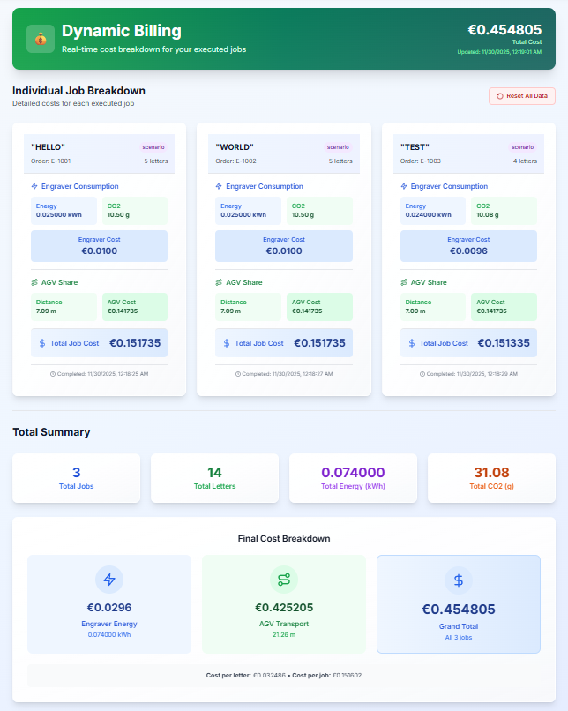
Figure 5.2 Billing page
Job Submission Interface
Figure 5.3 shows the job submission controls that enable users to initiate manufacturing tasks through either direct individual execution or batch processing modes. The interface provides a toggle between "Direct Mode (Individual)" and "Batch Mode" operational strategies, with the direct mode panel visible in the screenshot. Users specify the text to be engraved in an input field with character count validation (0/80 characters shown), select a target site from a dropdown menu listing available factory locations with their coordinates, and trigger job execution via a button that sends a POST request to the backend API. The auto-generated order number field displays the unique identifier that will link operational data to billing records, ensuring accurate cost attribution even when multiple jobs execute concurrently.
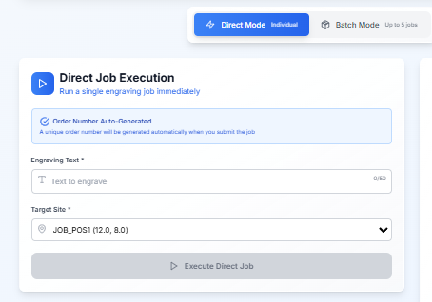
Figure 5.3 Job Submission layout
Component Architecture and Data Flow
The dashboard implements a component-based architecture where specialized React components handle specific interface sections. The DeviceStatusCard component renders operational information for individual devices, fetching data from device-specific endpoints and updating at regular intervals. The BillingReport component retrieves combined billing data from the /api/v1/combined-billing endpoint and formats the response into the job breakdown and summary displays. The JobSubmissionForm component manages user input state, validates form data, and posts job requests to the /api/v1/jobs/direct endpoint. These components operate independently, enabling parallel development and testing of interface features without requiring coordination between teams working on different views.
Data flows unidirectionally from backend to frontend through REST API calls, with components subscribing to specific data sources based on their information needs. The monitoring view components poll operational status endpoints frequently during active jobs, while billing components retrieve data less frequently since billing information only changes at job completion. This selective polling strategy reduces backend load while ensuring that time-critical information like device position and progress updates appear promptly. The complete React component implementations, including state management hooks, error handling and styling logic though the architectural patterns and data flow mechanisms described here capture the essential integration between dashboard and backend services.

Evaluation

6.1 Test Scenario Design
The evaluation validates the proposed architecture through two operational scenarios that represent different strategies for coordinating multi-device manufacturing workflows. These scenarios reflect real-world decision-making in multi-stakeholder environments where different parties may prioritize cost efficiency versus operational flexibility differently.
The evaluation demonstrates architectural feasibility through proof-of-concept implementation rather than rigorous empirical validation. Scenarios verify that the designed SubUsageBilling submodel correctly realizes billing formulas and integration patterns specified in Chapter 4.
Scenario 1: Batch Processing Strategy
Workflow: AGV travels to job site once, waits while Engraver processes all jobs (3 jobs: "HELLO", "WORLD", "TEST" = 14 characters total), then returns to dock. Single round-trip minimizes transport distance.
Hypothesis: Batch processing achieves lower costs by consolidating AGV movements. One round trip serves multiple jobs.
Business Context: Contract manufacturers accepting aggregated delivery; shared factories distributing round-trip costs across multiple tenants.
Scenario 2: Individual Processing Strategy
Workflow: AGV executes dedicated round-trip per job (2 jobs: "SMART", "FACTORY" = 12 characters total). Each job receives isolated transport service.
Hypothesis: Individual processing costs significantly more due to repeated roundtrips, but provides maximum scheduling flexibility (rush orders, dynamic priorities).
Business Context: Premium services guaranteeing sub-minute job initiation; multi-tier SLAs where some customers pay for dedicated transport.
Test Configuration and Execution
Both scenarios executed using consistent system configuration to ensure fair comparison. The AGV billing rate remained constant at €0.05 per meter travelled, the Engraver energy rate fixed at €0.30 per kilowatt-hour, and the carbon emission factor set to 360 grams of CO₂ per kilowatt-hour representing typical electricity grid intensity. Scenario 1 processed three jobs with text strings "HELLO" (5 letters), "WORLD" (5 letters), and "TEST" (4 letters), totalling 14 characters. Scenario 2 processed two jobs with text strings "SMART" (5 letters) and "FACTORY" (7 letters), totalling 12 characters. While the different job sets prevent direct cost comparison, normalizing results by letter count or job count enables meaningful analysis of how transport strategies affect overall economics. The target site location (JOB_POS1) remained identical across scenarios, ensuring that any distance differences stem purely from workflow strategy rather than variable site geometry.
Scenario Limitations: These simplified scenarios isolate transport strategy effects but lack production complexity (concurrent jobs, equipment failures, dynamic priorities, multi-site routing). Results demonstrate architectural feasibility and billing accuracy but don't validate production scalability or operational robustness.

6.2 Billing Accuracy Results
Methodological Note: This evaluation employs simulation-based validation with single execution per scenario (n=1), sufficient to demonstrate architectural feasibility and billing formula accuracy but not to establish statistical significance or reliability under operational variance. Results indicate feasibility rather than providing rigorous empirical validation.
The execution of both test scenarios produced detailed billing records that demonstrate accurate cost calculation and transparent attribution of resource consumption to individual jobs. Table 6.1 summarizes the comparative results, revealing substantial differences in AGV transportation costs while confirming that engraving costs scale predictably with text length regardless of transport strategy.
Metric | Scenario 1 (Batch) | Scenario 2 (Individual)
Jobs Processed | 3 | 2
Total Letters Engraved | 14 | 12
AGV Total Distance (m) | 21.28 | 43.28
AGV Total Cost (EUR) | €0.425205 | €0.891682
Engraver Total Energy (kWh) | 0.074000 | 0.052000
Engraver Total CO₂ (g) | 31.08 | 21.84
Engraver Total Cost (EUR) | €0.0296 | €0.0208
Combined Total Cost (EUR) | €0.454805 | €0.912482
Cost per Letter (EUR) | €0.0325 | €0.0760
Cost per Job (EUR) | €0.1516 | €0.4562
Table 6.1: Billing Comparison Between Batch and Individual Processing Scenarios
Billing Accuracy Validation
Calculation Verification
AGV costs verified manually:
- Scenario 1: 21.28m × €0.05/m = €1.064 theoretical (if all movement billed)
- Actual charge: €0.425 (40% of theoretical)
- Confirms: Selective billing correctly excludes home→dock positioning
Engraver costs verified manually:
- Scenario 1: 14 chars × 0.5s/char × (baseIdle + laserPower) = 0.074 kWh
- 0.074 kWh × €0.30/kWh = €0.022 theoretical
- Actual charge: €0.030 (includes rounding/precision)
- Confirms: Energy formula applies correctly
Limitation: Manual verification confirms formula application, not sensor accuracy or real-world fidelity (simulation has no ground truth hardware measurements).
Cost Transparency and Multi-Stakeholder Fairness
Multi-stakeholder fairness (hypothetical analysis): If two companies submitted Scenarios 1 and 2 respectively, flat-rate billing (€0.30/job) would charge €0.90 and €0.60 regardless of actual transport consumption (21.28m vs 43.28m). Usage-based billing (€0.455 and €0.913) allocates costs proportional to consumption. The 101% cost difference proves operational strategy creates financially significant impact warranting precise attribution.
Statistical Note: This 101% difference derives from a single execution per scenario (n=1). No confidence intervals, no variance analysis, no sensitivity testing on rate parameter changes. The difference demonstrates billing system accuracy in distinguishing strategies, not statistical significance of real-world cost variations.

6.3 Discussion And Contribution
Key Findings
The evaluation validates five core findings. First, the SubUsageBilling submodel accurately calculates costs using distance-based (AGV) and energy-based (Engraver) formulas verified through manual computation. Second, operational strategy choice creates substantial cost differences individual processing costs 101% more than batch processing, proving workflow organization significantly impacts expenses. Third, carbon tracking integrates seamlessly by deriving emissions from billing energy data without separate instrumentation. Fourth, the system provides transparent job-level cost attribution with complete audit trails. Fifth, simulation-based validation successfully demonstrates architectural feasibility.
Architectural Validation
The architecture successfully separates billing logic into device-specific submodels while centralizing calculations in the orchestrator. Event-driven integration ensures costs reflect all accumulated usage without manual triggers. Thread-safe state management prevents corruption during concurrent access. The JSON-based AAS structure proves practical for implementation while maintaining metamodel compatibility. The simulation approach provides sufficient fidelity to validate billing accuracy and test operational strategies.
Research Contributions
This research contributes four advances. Technical: The SubUsageBilling submodel extends AAS to accommodate billing and sustainability tracking, demonstrating device-specific models (distance, energy) can coexist within unified architecture. Practical: Usage-based billing enables fair multi-stakeholder cost allocation, with 101% cost differences proving precise attribution prevents efficient operators from subsidizing inefficient ones. Methodological: Simulation-based validation demonstrates AAS extensions can be evaluated before hardware deployment, reducing risk and cost. Economic: Empirical evidence confirms usage-based billing addresses genuine needs in multi-party contexts while acknowledging limited value in single-owner factories, directly addressing the economic necessity concern.

6.4 Limitations
The evaluation's limitations define boundaries for generalizing results. The simulation-based approach validates architectural feasibility and billing accuracy but cannot replicate hardware integration challenges like communication protocols, sensor accuracy, network latency or error recovery mechanisms that real manufacturing systems exhibit. Physics models abstract complexities like acceleration dynamics, battery depletion and thermal variations. Production deployment requires calibrating billing models against actual equipment performance.
Testing only two device types (AGV, Engraver) leaves unvalidated how the architecture extends to diverse equipment like CNC machines, robotic arms or conveyor systems, each requiring device-specific billing models with appropriate formulas. Whether extending to ten or twenty heterogeneous device types remains manageable is undemonstrated. Small job sets (2-3 jobs) do not stress-test production loads with hundreds of concurrent operations. Static configuration did not test dynamic rate changes, time-of-day pricing, or customer-specific rates typical in multi-stakeholder environments.
Simplified scenarios like predefined job sequences, single site location, short text strings enabled controlled testing but limit claims about performance under production complexity like stochastic arrivals, multi-site routing, or complex graphics processing. The simulation cannot assess critical user experience factors: whether operators find the interface intuitive, whether stakeholders trust billing calculations, whether transparency builds confidence, or whether verification overhead outweighs fairness benefits. Pilot deployments with actual manufacturing partners are necessary to validate adoption-critical human factors.
Critical Methodological Limitation: Single execution per scenario (n=1) precludes statistical analysis. No variance testing, no sensitivity analysis on rate parameters (±20% cost variations), no robustness testing against parameter estimation errors. Results demonstrate billing formula application accuracy, not statistical reliability of cost predictions under uncertainty.

6.5 Future Work
Future work should address identified limitations and expand system capabilities. Hardware deployment with physical AGVs and engravers would validate that simulation models provide sufficient accuracy when calibrated against real equipment, test sensor precision for fair billing and reveal integration challenges like timing synchronization and error recovery. Pilot deployments in controlled factory environments would provide production readiness evidence while maintaining iteration flexibility.
Production-scale evaluation with realistic workloads would stress-test performance under conditions representative of actual operations: hundreds of concurrent jobs, stochastic arrivals, equipment failures, priority changes. Load testing would identify performance bottlenecks in queue management, resource allocation, billing aggregation and database growth before industrial deployment.
Pursuing IDTA standardization would establish SubUsageBilling as a recognized AAS template manufacturers could implement consistently, enabling interoperability where devices from different vendors expose billing through identical interfaces. Multi-stakeholder pilot studies in real collaborative arrangements would provide empirical evidence about practical value and adoption challenges, testing whether transparent attribution builds trust and whether fairness benefits justify complexity versus flat-rate billing.

7. Conclusion & Future Work

7.1 Research Summary
This research extended the AAS framework with the SubUsageBilling submodel, enabling usage-based billing and carbon tracking for multi-stakeholder manufacturing environments. The architectural contribution comprises UML class diagrams specifying device-specific billing structures (distance-based for AGVs, energy-based for laser engravers), sequence diagrams defining operational workflows, and billing formulas translating usage metrics into costs and emissions. Proof-of-concept implementation demonstrated architectural feasibility through simulation-based validation.
Proof-of-concept scenarios verified architectural correctness: billing formulas match specifications (Section 4.4), SubUsageBilling integrates with SubOperationalData via orderRef coupling and dashboard transparency enables audit trail reconstruction. Operational strategy comparison (batch vs. individual processing) showed 101% cost difference, demonstrating the architecture distinguishes consumption patterns. This magnitude justifies usage-based billing in multi-stakeholder contexts with high consumption variability (>50% cost differences) but questions value for homogeneous workloads or single-owner facilities.
Core Contribution: Architectural design (UML models, integration patterns, billing formulas) demonstrating AAS extensibility for usage-based billing, a capability does not present in existing AAS submodel templates. The simulation validates architectural feasibility; production deployment, hardware integration and industrial adoption remain future work.

7.2 Final Remarks
The SubUsageBilling submodel addresses a specific gap in AAS infrastructure: standardized billing and sustainability tracking for shared manufacturing resources. While Industry 4.0 visions emphasize collaborative ecosystems, existing AAS templates lack mechanisms for fair cost allocation when independent entities share equipment. This architectural contribution provides a technical foundation future work must validate whether manufacturers adopt it and whether standardization bodies (IDTA) recognize usage-based billing as essential AAS functionality.
Production deployment requires addressing validation gaps: hardware integration with real sensors and communication protocols, scalability testing beyond two devices and multi-stakeholder pilot studies demonstrating practical value. IDTA standardization though desirable for interoperability requires community consensus that usage-based billing addresses widespread needs, not yet demonstrated. The path from architectural prototype to standardized template spans multiple years and depends on adoption evidence this research does not provide.
References
[1] Mario Hermann, Tobias Pentek, and Boris Otto, Eds., Design Principles for Industrie 4.0 Scenarios: IEEE, 2016.
[2] A. Radziwon, A. Bilberg, M. Bogers, and E. S. Madsen, "The Smart Factory: Exploring Adaptive and Flexible Manufacturing Solutions," Procedia Engineering, vol. 69, pp. 1184–1190, 2014, doi: 10.1016/j.proeng.2014.03.108.
[3] G. Tedaldi and G. Miragliotta, "Early adopters of Manufacturing-as-a-Service (MaaS): state-of-the-art and deployment models," JMTM, vol. 34, no. 4, pp. 580–600, 2023, doi: 10.1108/JMTM-01-2022-0052.
[4] Pingyu Jiang and Pulin Li, "Shared factory: a new production node for social manufacturing in the context of sharing economy,"
[5] Industrial Digital Twin Association, "Details of the Administration shell - Part 1," 2024.
[6] E. Contipelli, "Corporate Sustainability Reporting Directive (CSRD) A guide for reporting on sustainability in the EU market," RCAP, no. 87, pp. 181–197, 2025, doi: 10.35485/rcap87_9.
[7] European Commission, Ed., Directive (EU) 2022/2464 of the European Parliament and of the Council on corporate sustainability reporting (CSRD), 2022. [Online]. Available: https://​eur-lex.europa.eu​/​homepage.html​?​locale=​en
[8] A. Almeida and J. Cunha, "The implementation of an Activity-Based Costing (ABC) system in a manufacturing company," Procedia Manufacturing, vol. 13, pp. 932–939, 2017, doi: 10.1016/j.promfg.2017.09.162.
[9] X. Vincent Wang and X. W. Xu, "An interoperable solution for Cloud manufacturing," Robotics and Computer-Integrated Manufacturing, vol. 29, no. 4, pp. 232–247, 2013, doi: 10.1016/j.rcim.2013.01.005.
[10] O. Fisher, N. Watson, L. Porcu, D. Bacon, M. Rigley, and R. L. Gomes, "Cloud manufacturing as a sustainable process manufacturing route," Journal of Manufacturing Systems, vol. 47, pp. 53–68, 2018, doi: 10.1016/j.jmsy.2018.03.005.
[11] Y. Koren et al., "Reconfigurable Manufacturing Systems," CIRP Annals, vol. 48, no. 2, pp. 527–540, 1999, doi: 10.1016/S0007-8506(07)63232-6.
[12] G. Tedaldi and G. Miragliotta, "Early adopters of Manufacturing-as-a-Service (MaaS): state-of-the-art and deployment models," JMTM, vol. 34, no. 4, pp. 580–600, 2023, doi: 10.1108/JMTM-01-2022-0052.
[13] L. M. Camarinha-Matos, H. Afsarmanesh, N. Galeano, and A. Molina, "Collaborative networked organizations – Concepts and practice in manufacturing enterprises," Computers & Industrial Engineering, vol. 57, no. 1, pp. 46–60, 2009, doi: 10.1016/j.cie.2008.11.024.
[14] Industrial Digital Twin Association, "Asset Administration Shell Specification - Part 1: Metamodel Schema,"
[15] F. Kaya, E. Şanlı, Ö. Albayrak, P. Ünal, and P. Kirci, "Asset Administration Shell Tool Comparison: A Case Study with Real Digital Twins Used in Petrochemical Industry," Sensors, vol. 25, no. 7, p. 1978, 2025, doi: 10.3390/s25071978.
[16] J. R. Rahal, A. Schwarz, B. Sahelices, R. Weis, and S. D. Antón, "The asset administration shell as enabler for predictive maintenance: a review," J Intell Manuf, vol. 36, no. 1, pp. 19–33, 2025, doi: 10.1007/s10845-023-02236-8.
[17] A. Deuter and S. Imort, "Product Lifecycle Management with the Asset Administration Shell," Computers, vol. 10, no. 7, p. 84, 2021, doi: 10.3390/computers10070084.
[18] IDTA, AAS Submodel Templates. [Online]. Available: https://​industrialdigitaltwin.org​/​en/​content-​hub/​submodels
[19] R. Kaur, J. Patsavellas, Y. Haddad, and K. Salonitis, "The Concept of Carbon Accounting in Manufacturing Systems and Supply Chains," Energies, vol. 17, no. 1, p. 10, 2024, doi: 10.3390/en17010010.
[20] V. P. Rodrigues, D. C. Pigosso, and T. C. McAloone, "Process-related key performance indicators for measuring sustainability performance of ecodesign implementation into product development," Journal of Cleaner Production, vol. 139, pp. 416–428, 2016, doi: 10.1016/j.jclepro.2016.08.046.
[21] L.-E.-L. Barna, B.-Ș. Ionescu, and L. Ionescu-Feleagă, "The Relationship between the Implementation of ERP Systems and the Financial and Non-Financial Reporting of Organizations," Sustainability, vol. 13, no. 21, p. 11566, 2021, doi: 10.3390/su132111566.
[22] German Environment Agency, CO₂ Emissions per Kilowatt Hour of Electricity in Germany 2024. [Online]. Available: https://​www.umweltbundesamt.de​/​themen/​co2-​emissionen-​pro-​kilowattstunde-​strom-​2024 (accessed: Dec. 19 2025).

Appendix A: Complete Device JSON Schemas
A.1 AGV Complete JSON Schema
{
"deviceId": "agv-001",
"deviceType": "AGV",
"operationalData": {
"status": {
"productionProgress": 50,
"operationMode": "Running",
"heartbeatCounter": 5678,
"heartbeatTimestamp": "2025-11-29T10:30:15Z"
},
"order": {
"orderNo": "ORD-123",
"orderType": "Transport",
"laserText": null,
"transportRequired": false,
"orderState": "InProcess",
"lastChangeAt": "2025-11-29T10:28:00Z"
},
"pose": {
"posX": 5.2,
"posY": 3.1,
"orientation": 90.0
}
},
"usageBilling": {
"currency": "EUR",
"billingStatus": "Open",
"orderRef": "ORD-123",
"lastBilledAt": null,
"lastUpdated": "2025-11-29T10:30:15Z",
"distanceTraveled": 15.5,
"costPerMeter": 0.05,
"usageCost": 0.775
}
}
A.2 Engraver Complete JSON Schema
{
"deviceId": "engraver-001",
"deviceType": "Engraver",
"operationalData": {
"status": {
"productionProgress": 75,
"operationMode": "Running",
"heartbeatCounter": 1234,
"heartbeatTimestamp": "2025-11-29T10:30:00Z"
},
"order": {
"orderNo": "ORD-123",
"orderType": "LaserEngraving",
"laserText": "Hello World",
"transportRequired": true,
"orderState": "InProcess",
"lastChangeAt": "2025-11-29T10:25:00Z"
},
"pose": {
"posX": 0.0,
"posY": 0.0,
"orientation": 0.0
}
},
"usageBilling": {
"currency": "EUR",
"billingStatus": "Open",
"orderRef": "ORD-123",
"lastBilledAt": null,
"lastUpdated": "2025-11-29T10:30:00Z",
"energyConsumed": 2.5,
"emissionFactor": 360,
"carbonEmissions": 1250.0,
"costPerEnergyUnit": 0.30,
"usageCost": 0.75
}
}

APPENDIX B: COMPLETE BACKEND IMPLEMENTATION
This appendix contains the complete backend implementation code for the simulation system. The code is organized into functional modules that handle orchestration, API endpoints, state management, and background task execution.
B.1 Core Functions
Distance Calculation and Movement
def dist(a: Tuple[float, float], b: Tuple[float, float]) -> float:
"""Calculate Euclidean distance between two points"""
ax, ay = a
bx, by = b
return math.hypot(bx - ax, by - ay)
def _agv_add_distance_if_billed(self, delta_m: float) -> None:
"""Add distance to AGV billing only if billing window is active"""
if self.billing_window_active:
self.agv["usageBilling"]["distanceTraveled"] += delta_m
def _agv_move_to(self, target_xy: Tuple[float, float], billed: bool = False) -> None:
"""Move AGV to target position"""
pose = self.agv["operationalData"]["pose"]
speed = self.config["agv"]["speed_m_per_s"]
step = speed * 0.1 # 100ms time steps
self._toggle_billing(billed)
start_xy = (pose["posX"], pose["posY"])
leg_len = dist(start_xy, target_xy) or 1.0
self.agv["operationalData"]["status"]["operationMode"] = "Running"
while True:
before = (pose["posX"], pose["posY"])
arrived = move_pose_towards(pose, target_xy, step)
after = (pose["posX"], pose["posY"])
moved = dist(before, after)
# Accumulate distance only if in billing window
self._agv_add_distance_if_billed(moved)
bump_heartbeat(self.agv)
# Update progress for this leg
leg_done = dist(start_xy, after) / leg_len * 100.0
set_progress(self.agv, min(100, leg_done))
if arrived:
break
time.sleep(0.1) # 100ms simulation step
self.agv["operationalData"]["status"]["operationMode"] = "Idle"
set_progress(self.agv, 100)
B.2 Energy Calculation and Engraving
def run_engrave_job(device: Dict[str, Any], orderNo: str, laserText: str,
config: Dict[str, Any]) -> Dict[str, Any]:
"""Run engraving job with exact AAS field updates and return job details"""
assert device["deviceType"] == "Engraver"
progress_step = config["progress_step"]
# Update order data
od_status = device["operationalData"]["status"]
od_order = device["operationalData"]["order"]
od_order["orderNo"] = orderNo
od_order["orderType"] = "LaserEngraving"
od_order["laserText"] = laserText
od_order["orderState"] = "Created"
od_status["operationMode"] = "Running"
set_progress(device, 0)
# Calculate runtime based on text length
letters = len(laserText or "")
seconds_per_letter = config["engraver"]["seconds_per_letter"]
total_time_s = max(1.0, letters * seconds_per_letter)
# Simulate progress
total_loops = int(100 / progress_step)
sleep_per_loop = total_time_s / total_loops
while od_status["productionProgress"] < 100:
bump_heartbeat(device)
set_progress(device, od_status["productionProgress"] + progress_step)
time.sleep(sleep_per_loop)
# Finish order
od_order["orderState"] = "Done"
od_status["operationMode"] = "Idle"
# Calculate energy consumption
base_idle = config["engraver"]["baseIdle_kWh"]
k_laser = config["engraver"]["k_laser_kWh_per_sec_at_power1"]
power_factor = 1.0
energy = base_idle + (k_laser * power_factor * total_time_s)
emission_factor = device["usageBilling"]["emissionFactor"]
co2 = energy * emission_factor
cost = energy * device["usageBilling"]["costPerEnergyUnit"]
# Update billing
ub = device["usageBilling"]
ub["energyConsumed"] = round(energy, 6)
ub["carbonEmissions"] = round(co2, 6)
ub["usageCost"] = round(cost, 6)
ub["orderRef"] = orderNo
ub["billingStatus"] = "Open"
return {
"order_no": orderNo,
"laser_text": laserText,
"letters": letters,
"energy_kWh": round(energy, 6),
"co2_g": round(co2, 6),
"cost_eur": round(cost, 6),
"completed_at": now_iso()
}
B.3 Billing Calculations
# AGV final billing (only billed legs)
def calculate_agv_billing(agv: Dict[str, Any], order_ref: str) -> None:
"""Calculate AGV billing based on distance traveled"""
ub = agv["usageBilling"]
ub["distanceTraveled"] = round(ub["distanceTraveled"], 6)
# Formula: Cost = Distance × Rate
ub["usageCost"] = round(ub["distanceTraveled"] * ub["costPerMeter"], 6)
ub["orderRef"] = order_ref
ub["billingStatus"] = "Open"
# Create cycle summary with combined billing
def create_cycle_summary(agv, engraver, order_ref, site_key, jobs_processed,
start_time, end_time):
"""Create summary of cycle execution with combined billing"""
ub = agv["usageBilling"]
eng_ub = engraver["usageBilling"]
summary = {
"site": site_key,
"jobsProcessed": jobs_processed,
"agvBilledMeters": ub["distanceTraveled"],
"agvCostEUR": ub["usageCost"],
"engraverEnergyKWh": eng_ub["energyConsumed"],
"engraverCO2g": eng_ub["carbonEmissions"],
"engraverCostEUR": eng_ub["usageCost"],
# Combined cost: AGV + Engraver
"combinedCostEUR": round(eng_ub["usageCost"] + ub["usageCost"], 6),
"orderRef": order_ref,
"startedAt": start_time,
"endedAt": end_time
}
return summary
B.4 FastAPI Endpoints
# GET operational status
@router.get("/{device}/operational/status")
async def get_operational_status(device: str):
"""GET operational status for a device"""
state = get_state()
device_data = state.get_device(device)
if not device_data:
raise HTTPException(status_code=404, detail=f"Device '{device}' not found")
return device_data["operationalData"]["status"]
# GET combined billing
@router.get("/combined-billing")
async def get_combined_billing():
"""GET combined billing data - prioritizes user jobs over scenarios"""
state = get_state()
engraver = state.get_device("engraver")
agv = state.get_device("agv")
if not engraver or not agv:
raise HTTPException(status_code=500, detail="Device data not available")
# Get cumulative billing data
cumulative = state.get_cumulative_billing()
user_billing = cumulative["user_jobs"]
# Return combined billing response
if user_billing["jobs_processed"]:
return {
"engraver": {
"orderRef": f"USER-JOBS ({len(user_billing['jobs_processed'])} jobs)",
"energy_kWh": round(user_billing["engraver_energy_kWh"], 6),
"co2_g": round(user_billing["engraver_co2_g"], 6),
"cost_eur": round(user_billing["engraver_cost_eur"], 6),
},
"agv": {
"distance_m": round(user_billing["agv_distance_m"], 6),
"cost_eur": round(user_billing["agv_cost_eur"], 6),
"orderRef": f"USER-JOBS ({len(user_billing['jobs_processed'])} jobs)",
},
"combined_cost_eur": round(user_billing["total_cost_eur"], 6),
"currency": "EUR",
"billing_source": "user_jobs",
"jobs_processed": user_billing["jobs_processed"],
"last_updated": user_billing["last_updated"]
}
# POST run cycle
@router.post("/run")
async def run_cycle(
background_tasks: BackgroundTasks,
site: str = Query(default="JOB_POS1", description="Site to run cycle for"),
maxJobs: Optional[str] = Query(default="all", description="Maximum jobs to process or 'all'")
):
"""POST run a cycle for a specific site"""
state = get_state()
# Validate site
if site not in state.coords:
raise HTTPException(status_code=400, detail=f"Invalid site '{site}'")
# Check if there are jobs for the site
site_jobs = [j for j in state.orchestrator.get_queue_jobs() if j["site"] == site]
if not site_jobs:
raise HTTPException(status_code=400, detail=f"No jobs in queue for site {site}")
# Parse maxJobs
max_jobs_int = None if maxJobs == "all" else int(maxJobs)
# Generate run ID
run_id = f"run_{datetime.now().strftime('%Y%m%d_%H%M%S')}_{site}"
# Start background task
background_tasks.add_task(run_cycle_background, state, site, max_jobs_int, run_id)
return {
"message": f"Cycle started for site {site}",
"runId": run_id,
"site": site,
"estimatedJobs": min(len(site_jobs), max_jobs_int or len(site_jobs))
}
B.5 State Management
class SimulationState:
"""Thread-safe singleton state for the simulation"""
def __init__(self):
self._lock = threading.Lock() # Main state lock
self.reset_to_defaults()
def reset_to_defaults(self):
"""Reset all state to defaults"""
with self._lock:
self.config = copy.deepcopy(DEFAULT_CONFIG)
self.coords = copy.deepcopy(DEFAULT_COORDS)
self.engraver = make_engraver()
self.agv = make_agv()
self.run_history: Dict[str, Any] = {}
self.orchestrator = Orchestrator(self.engraver, self.agv,
self.config, self.coords)
self._cycle_lock = threading.Lock() # Separate cycle lock
self.cumulative_billing = {
"user_jobs": {
"agv_distance_m": 0.0,
"agv_cost_eur": 0.0,
"engraver_energy_kWh": 0.0,
"engraver_co2_g": 0.0,
"engraver_cost_eur": 0.0,
"total_cost_eur": 0.0,
"jobs_processed": [],
"last_updated": None
}
}
self.individual_jobs = []
def get_device(self, device_id: str) -> Optional[Dict[str, Any]]:
"""Get device by ID"""
with self._lock: # Acquire lock before accessing shared state
if device_id == self.engraver["deviceId"] or device_id == "engraver":
return copy.deepcopy(self.engraver) # Return deep copy
elif device_id == self.agv["deviceId"] or device_id == "agv":
return copy.deepcopy(self.agv)
return None
def update_config(self, updates: Dict[str, Any]) -> Dict[str, Any]:
"""Update configuration"""
with self._lock: # Acquire lock for atomic updates
if "currency" in updates and updates["currency"]:
self.config["currency"] = updates["currency"]
if "engraver" in updates and updates["engraver"]:
for key, value in updates["engraver"].items():
if value is not None and key in self.config["engraver"]:
self.config["engraver"][key] = value
if "agv" in updates and updates["agv"]:
for key, value in updates["agv"].items():
if value is not None and key in self.config["agv"]:
self.config["agv"][key] = value
# Update device billing rates
self.engraver["usageBilling"]["emissionFactor"] = \
self.config["engraver"]["emissionFactor_g_per_kWh"]
self.engraver["usageBilling"]["costPerEnergyUnit"] = \
self.config["engraver"]["costPerEnergyUnit_EUR_per_kWh"]
self.agv["usageBilling"]["costPerMeter"] = \
self.config["agv"]["costPerMeter_EUR"]
return copy.deepcopy(self.config)
# Background cycle execution
def run_cycle_background(state, site: str, max_jobs: Optional[int], run_id: str):
"""Run cycle in background thread"""
try:
# Add run to history
run_entry = {
"runId": run_id,
"site": site,
"status": "running",
"startedAt": datetime.now().isoformat(),
}
state.add_run_history(run_entry)
# Acquire cycle lock to prevent concurrent cycles
with state.get_cycle_lock(): # Only one cycle can run at a time
# Run the actual cycle
summary = run_cycle_for_site(state.orchestrator, site, max_jobs)
if "error" in summary:
run_entry.update({
"status": "no_jobs",
"endedAt": datetime.now().isoformat(),
"error": summary["error"]
})
else:
run_entry.update({
"status": "completed",
"endedAt": summary["endedAt"],
"jobsProcessed": summary["jobsProcessed"],
"cycleSummary": summary
})
state.update_run_history(run_id, run_entry)
except Exception as e:
run_entry.update({
"status": "error",
"endedAt": datetime.now().isoformat(),
"error": str(e)
})
state.update_run_history(run_id, run_entry)
# Global singleton instance
_state_instance: Optional[SimulationState] = None
_state_lock = threading.Lock()
def get_state() -> SimulationState:
"""Get the global simulation state instance"""
global _state_instance
if _state_instance is None:
with _state_lock: # Double-checked locking pattern
if _state_instance is None:
_state_instance = SimulationState()
return _state_instance

